This module used for persistence purpose

Before that, we are using JDBC but that has some limitation

1. Must and should have to use exception handling that mines each every code should be under try catch block or we can say all are **checked Exception** .
2. Programmer’s duty has to create connection and if programmer forgot to close connection then in background it will utilize resources so will get memory leakage problem.
3. We need to write so many duplicate code.

Ex: 10 servlet there each servlet performed different 2 operations

We have to write all the operation for each servlet these all-duplicate code is called as boiler plate code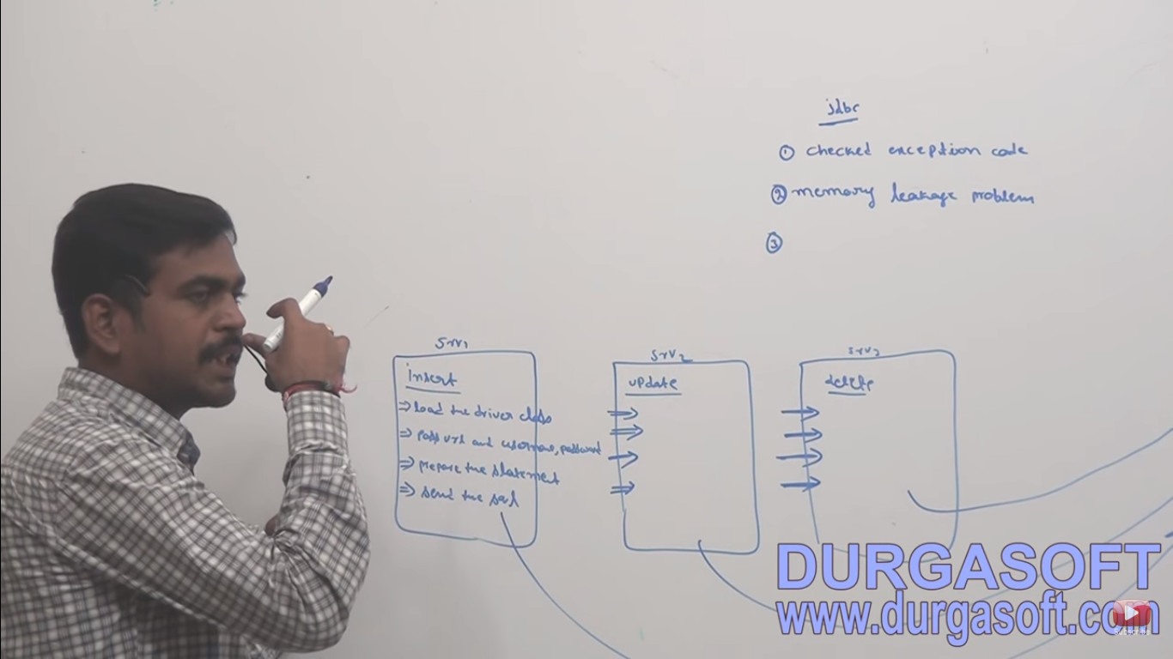

1. When ever we are using JDBC,then it will generate some error code Ex : ORA-666 this code programmer wont understand .

Overcome with this problem🡺 Spring with JDBC

* Without connection object we cannot perform
* Once we will get connection object next think we need to work with **DriverMangger Data source** Drivermanger is implemented by the predefine interface **data source**

Java.sql.datasor.

* In DataSource Interface has to predefine class DriverManagerDataSource(org.spring.framwork.idbc.datasource.*) and BasicDataSource(org.apache.commons.dbcp.*) both are using to getting a connections
* Use of DriverManagerDataSource- small level of applications
* Use of BasicDataSource – large or production level of applications

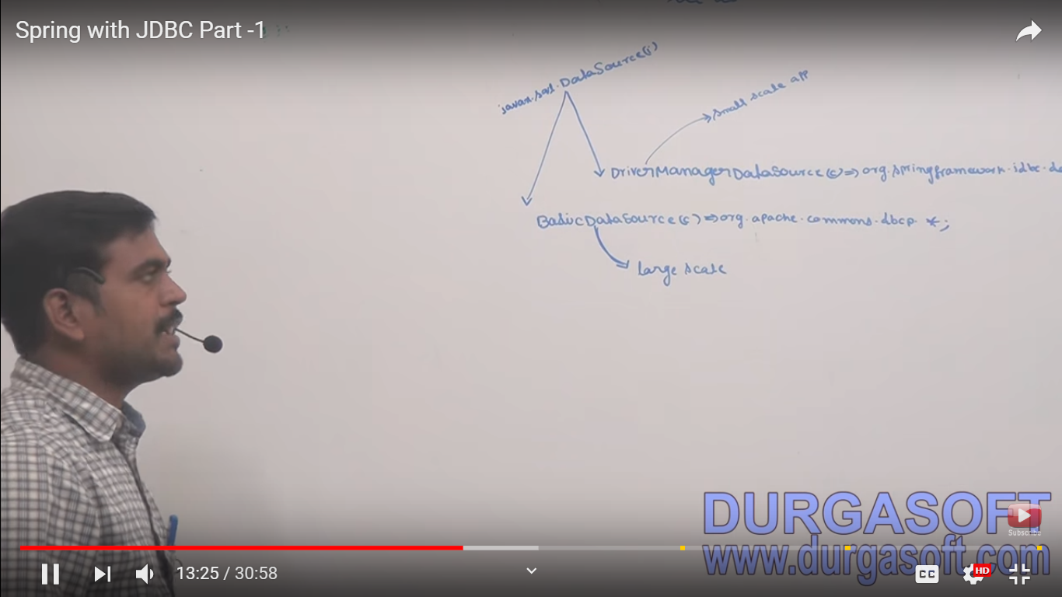

Now to configure in springconfig.xml

Under DTO

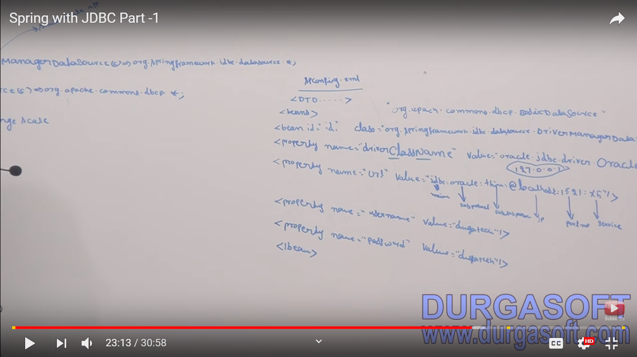

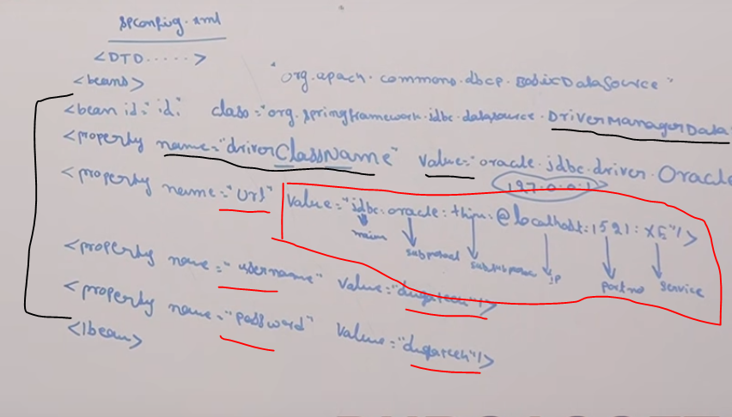

After getting data base connection object you need to perform data base operations:

So for data base operations Spring JDBC provide two centralized class

1. JDBC Template
2. Storedprodure

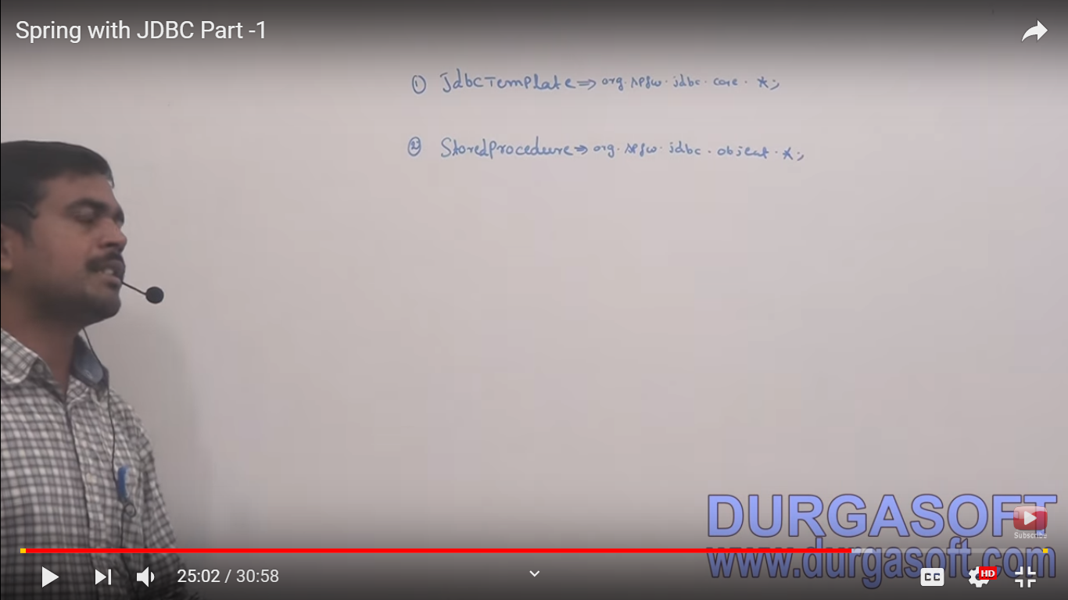

JDBC template has serval duty :

This follow template design pattern (Taking input and providing output)

1. To load driver class
2. Pass the url
3. Prepare statement
4. Sending query to frontend to backend application

There are predefine methods which is below

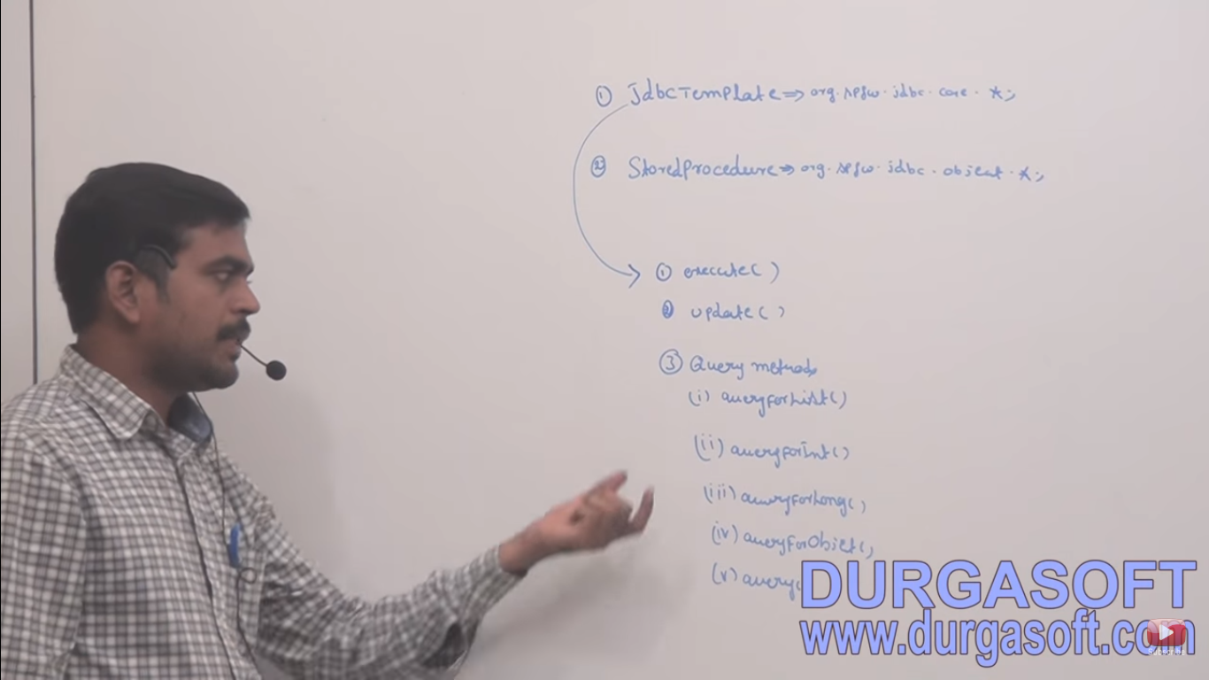

Description of those methods

With DDL,DML,DQl,DCL

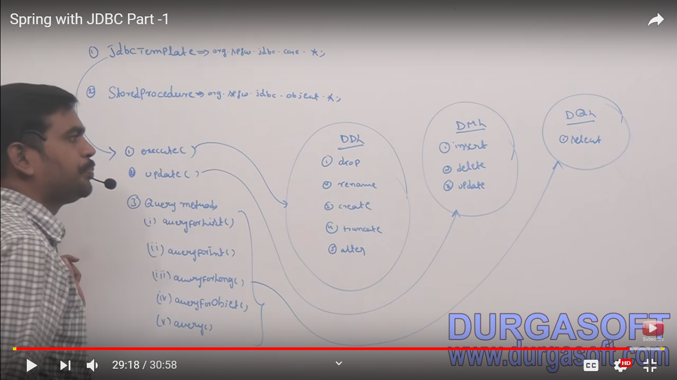

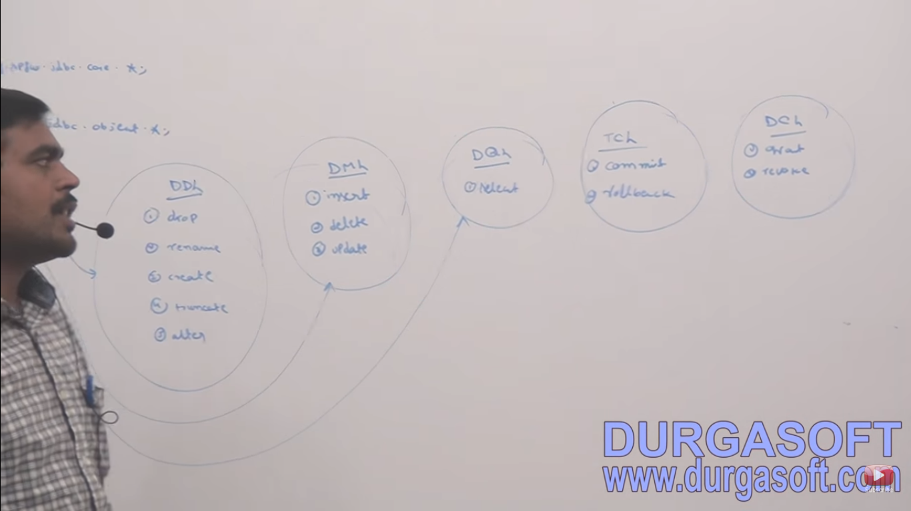

TCL for if you working with transaction

DCL for if you want to create your won sheama

1. We will take DemoBean as class

And this is we callit as Bussness component

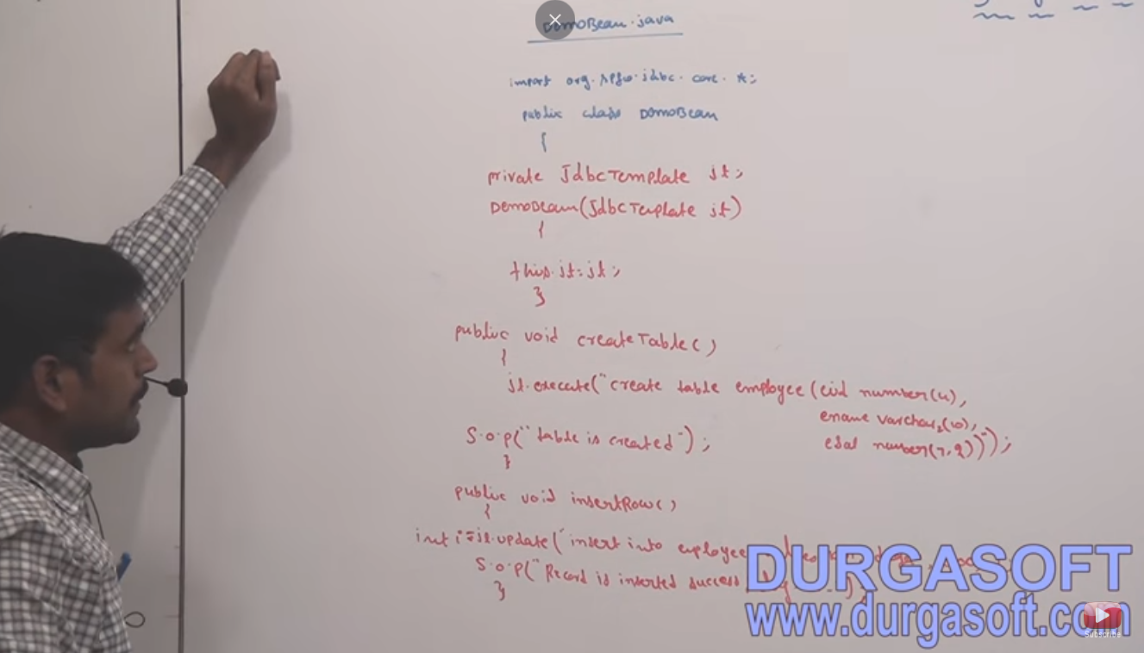

We need to configer 3 class inside springconfig.xml

1. For connection purpose Drivermangerdatasource
2. JDBC Template
3. Our class Demo Bean

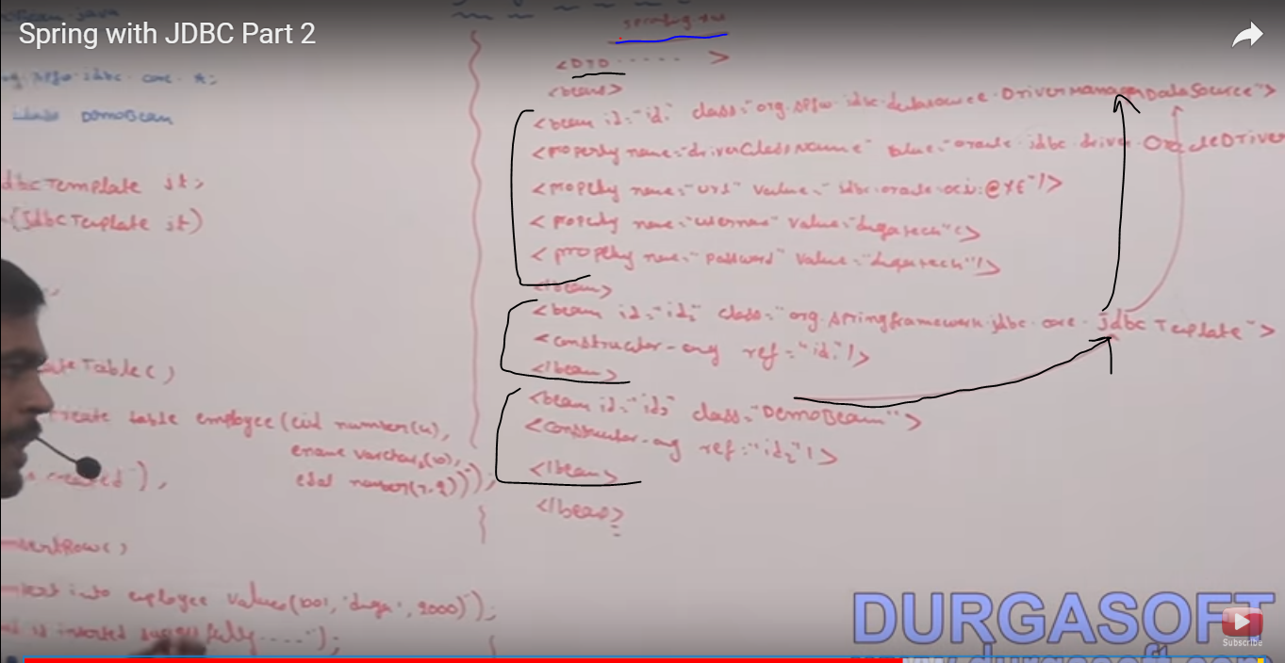

Client to test :(Client.java)

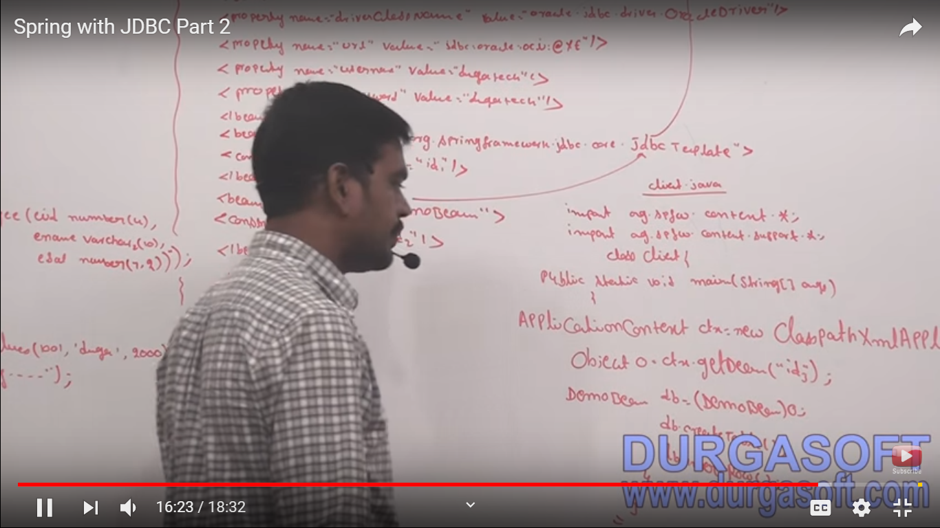

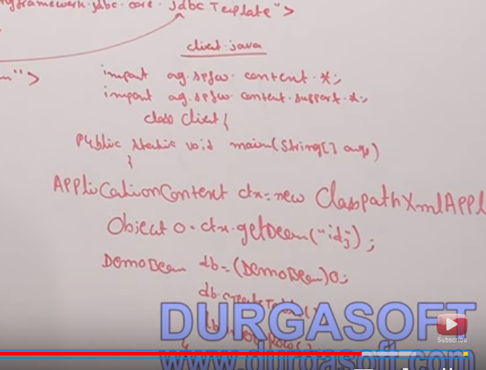

Required jar for Spring JDBC template

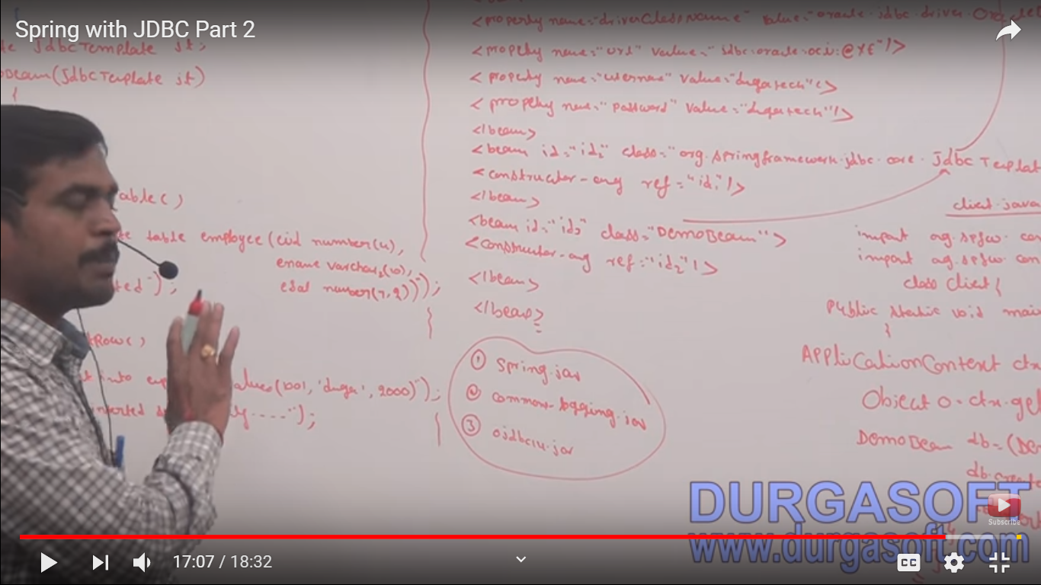

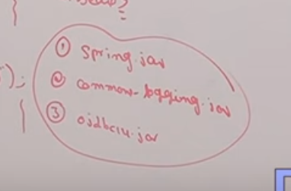

We need to set into class path

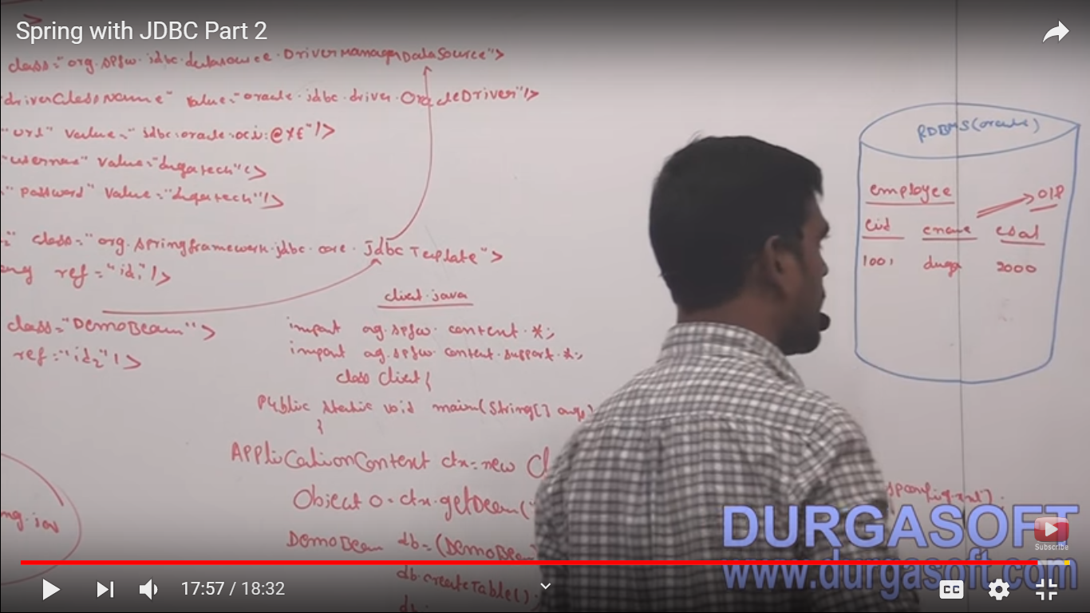

Creating project in Eclipse :

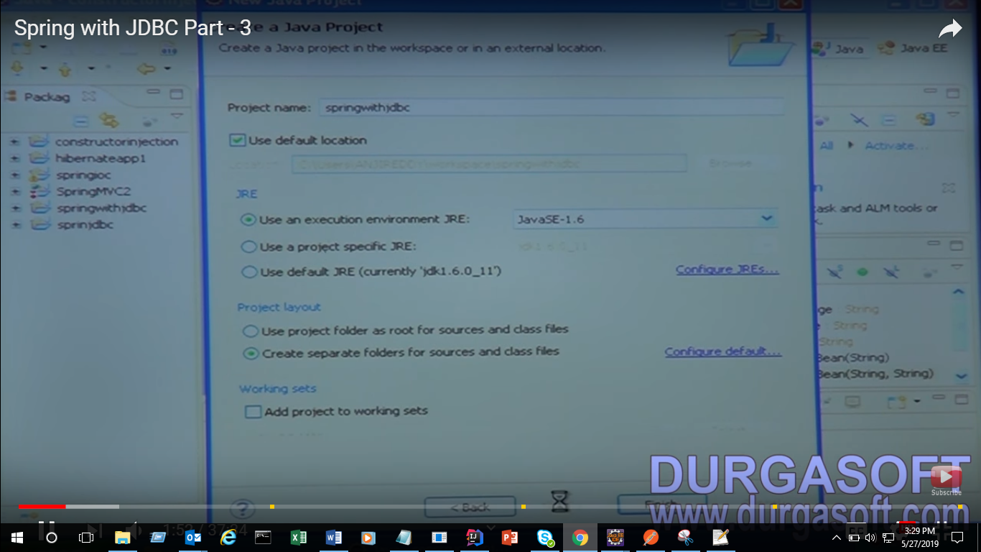

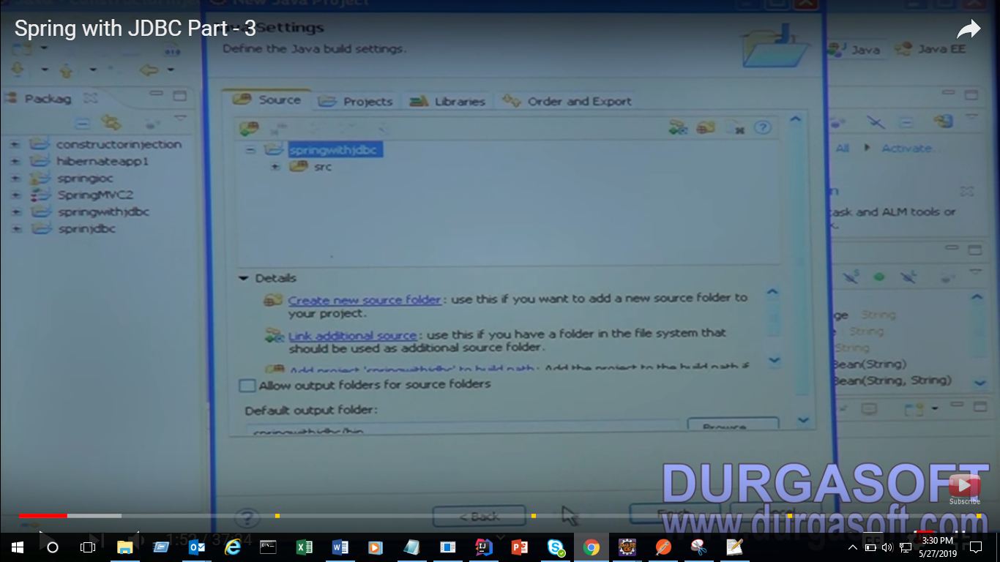

Adding jar

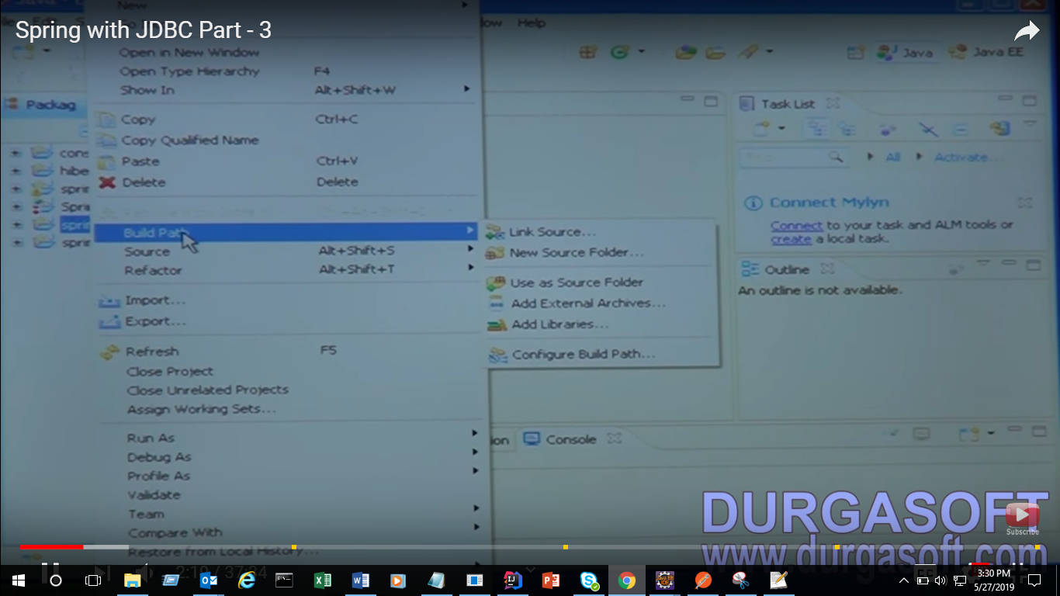

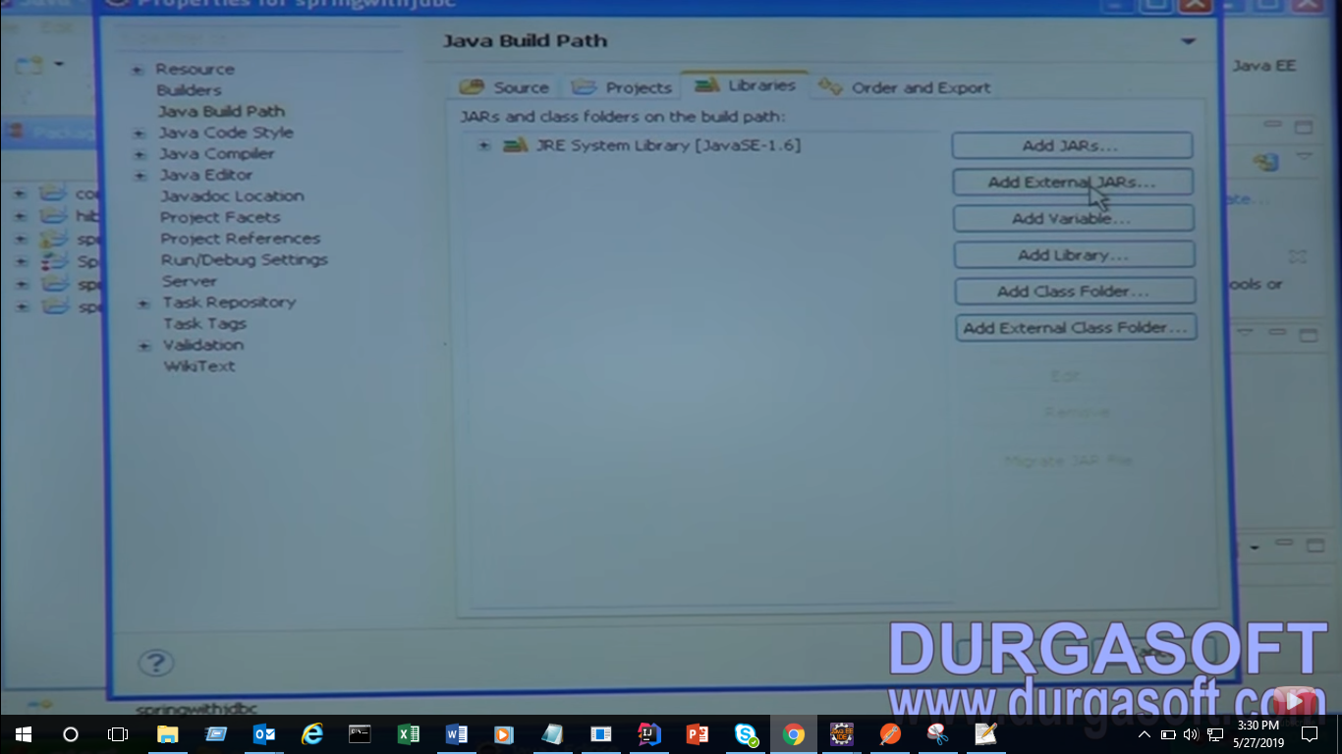

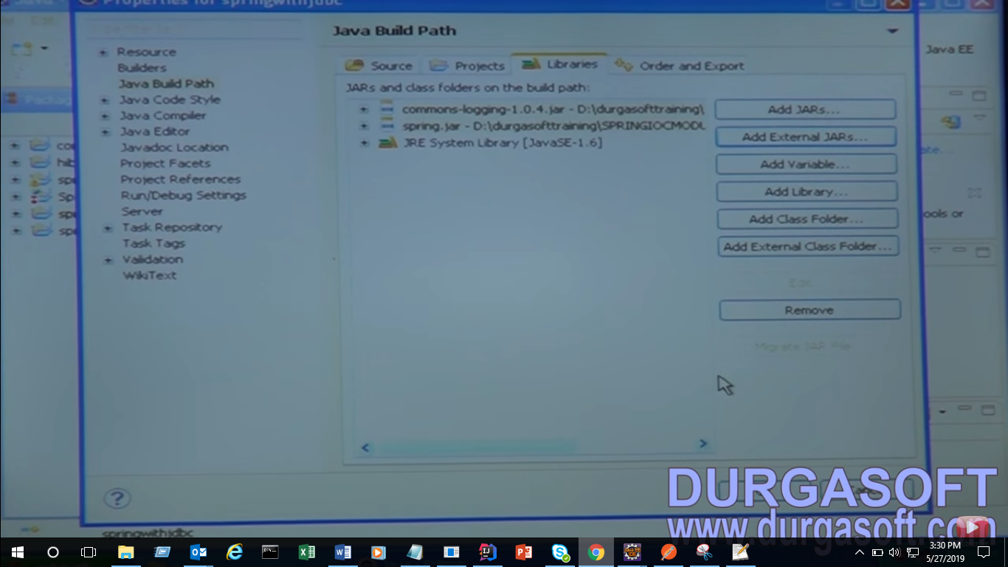

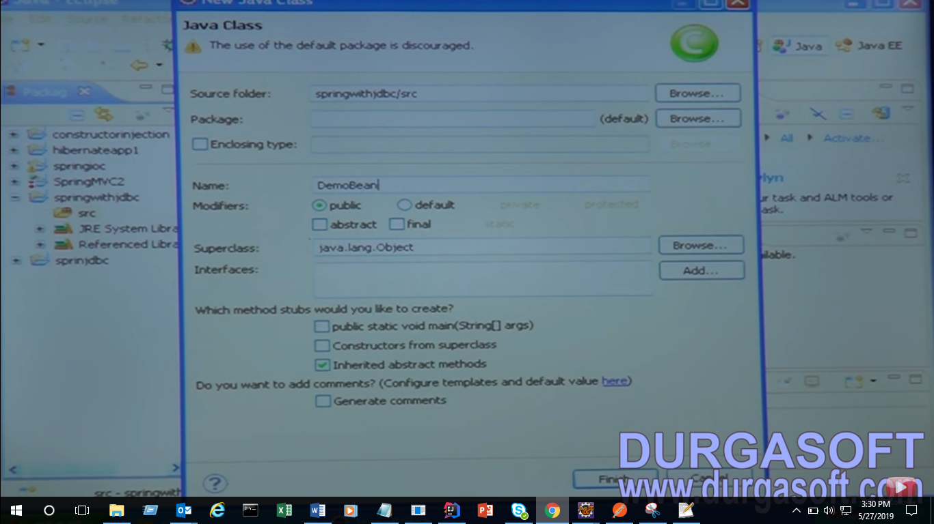

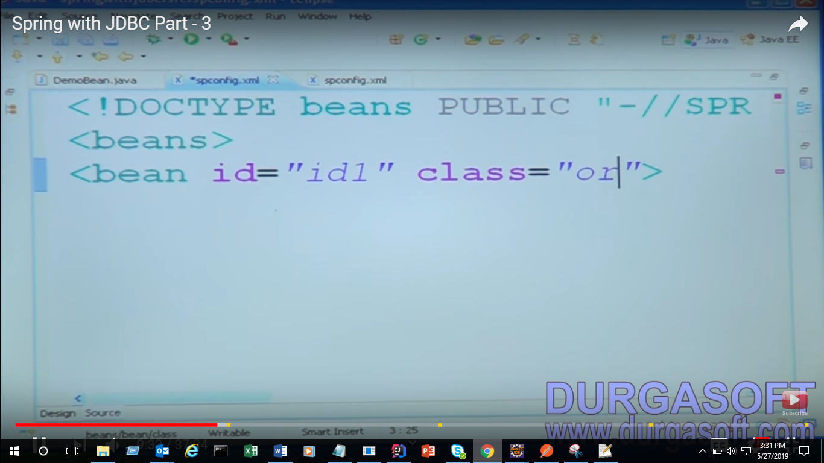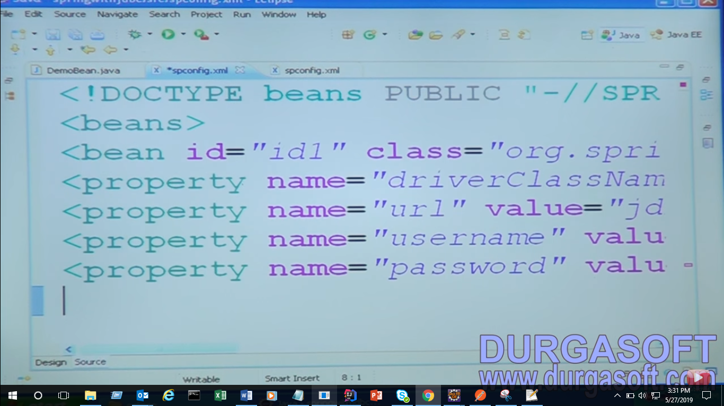

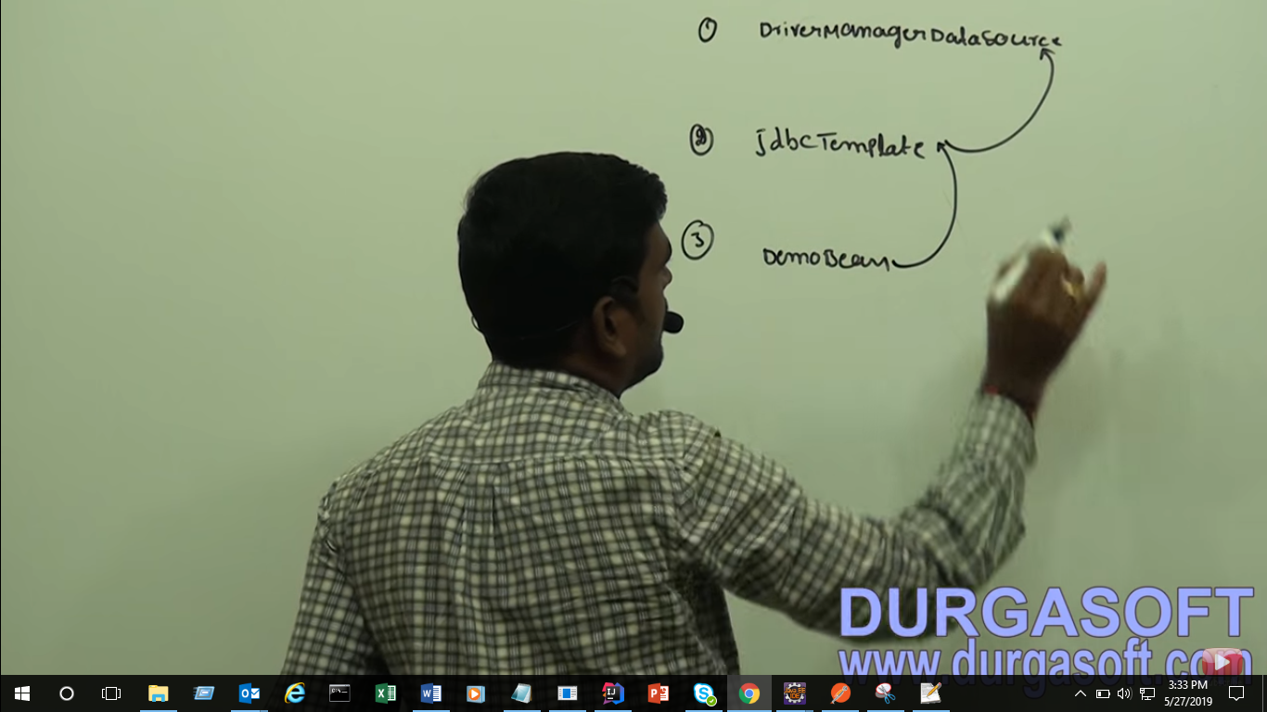

For Client

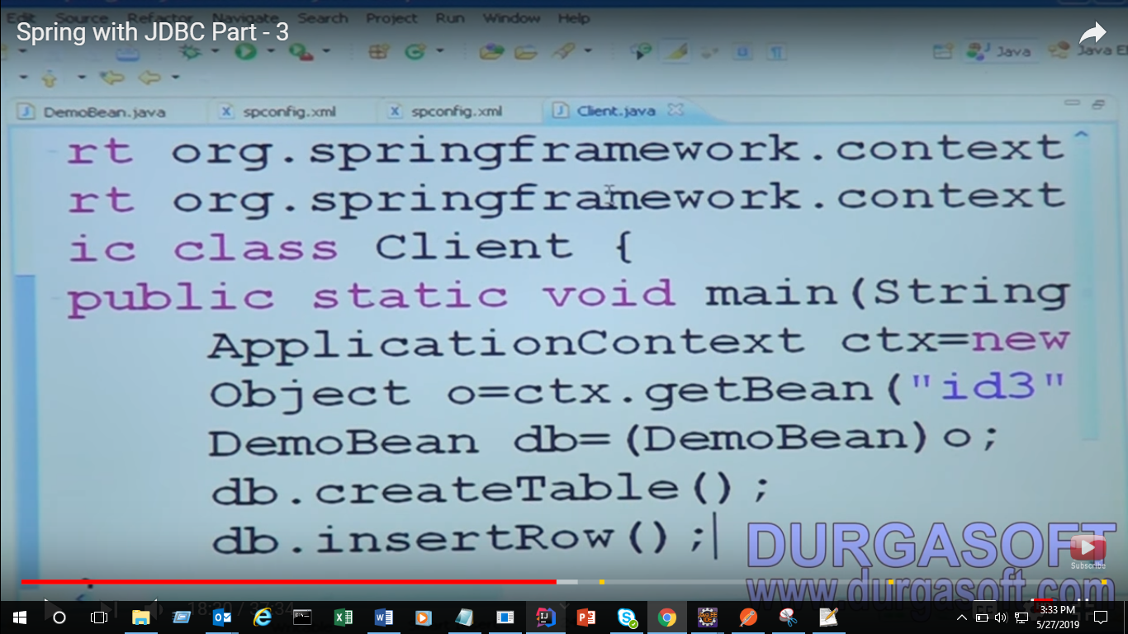

Now working With DB

Open Sql :



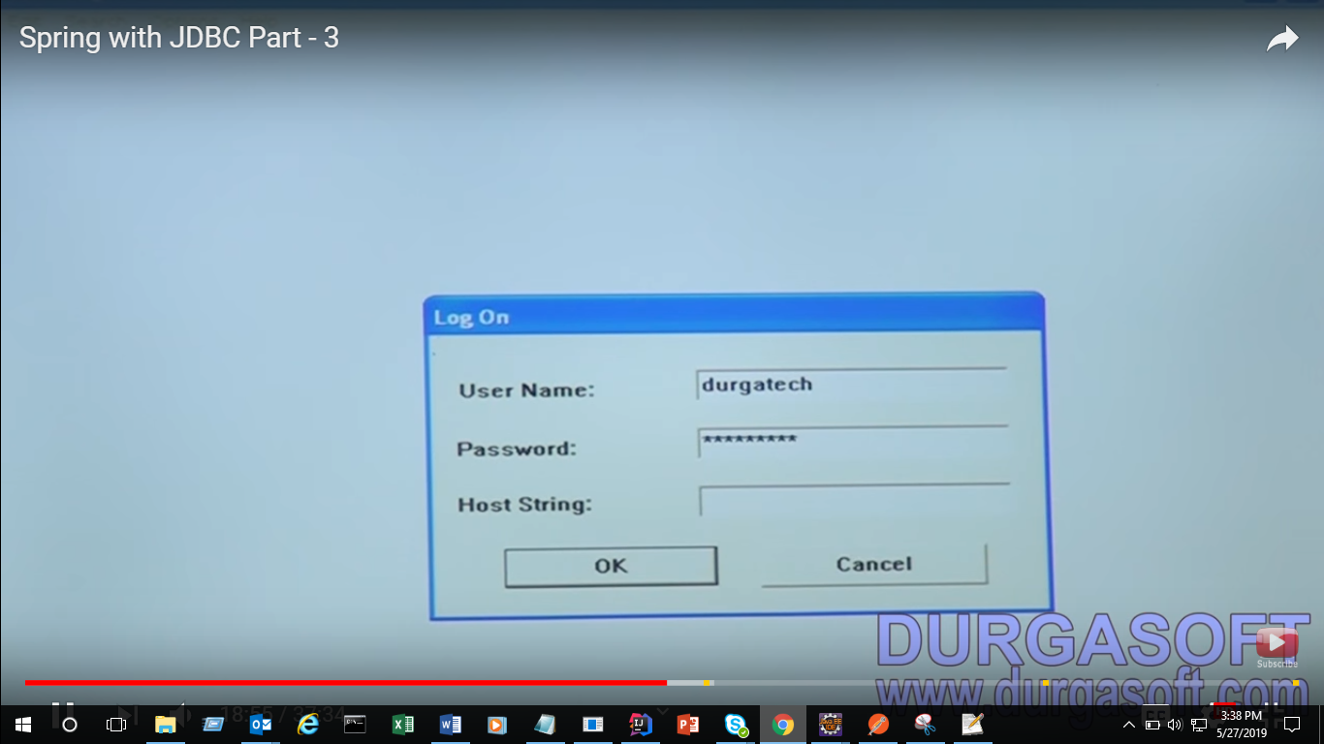

Now you open your user not admin

If you want to create your own user

1. Connect to sys as sysdba because its admin you can create user

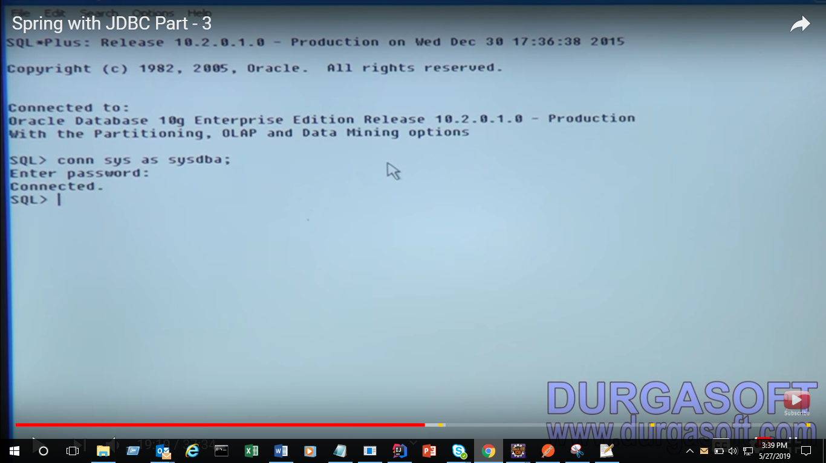

1. Drop user durgatech cascade;

In real-time no one is using scott and tiger

So create your own user

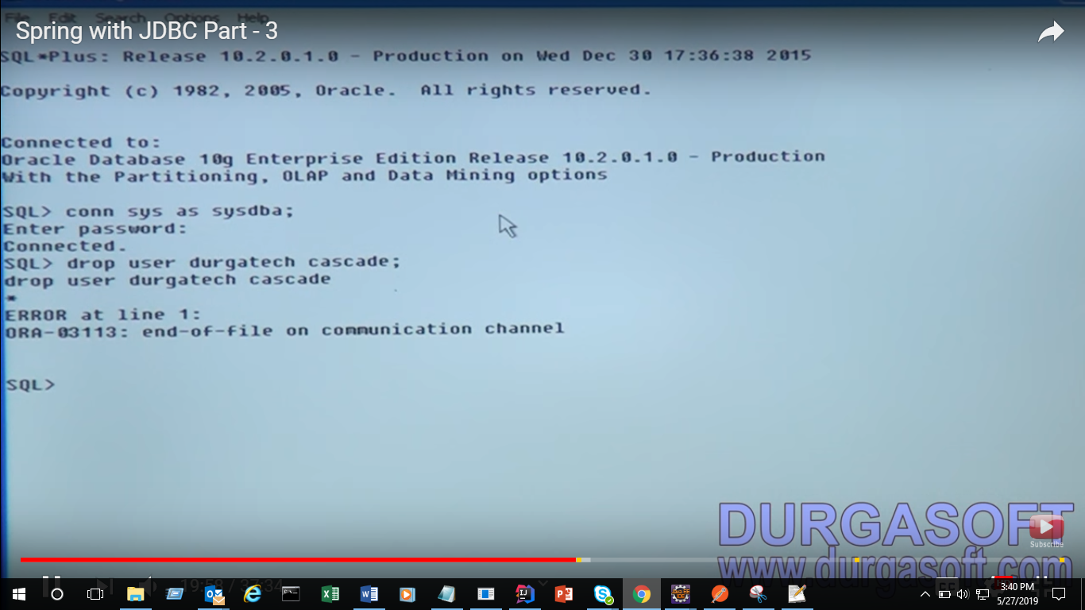

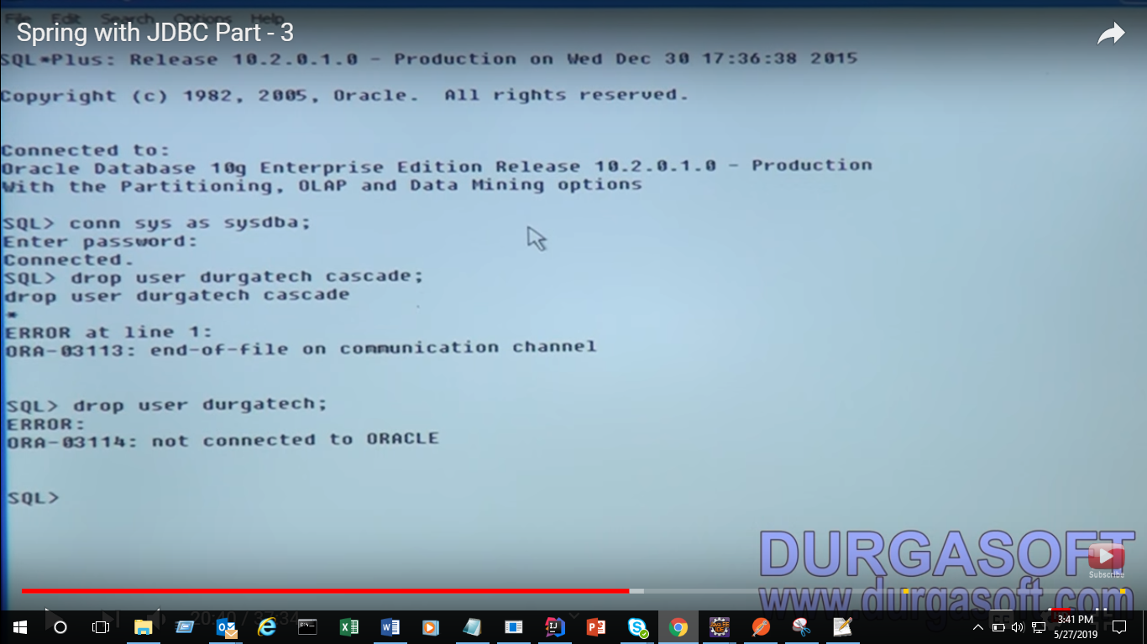

This error is because not connected to oracle

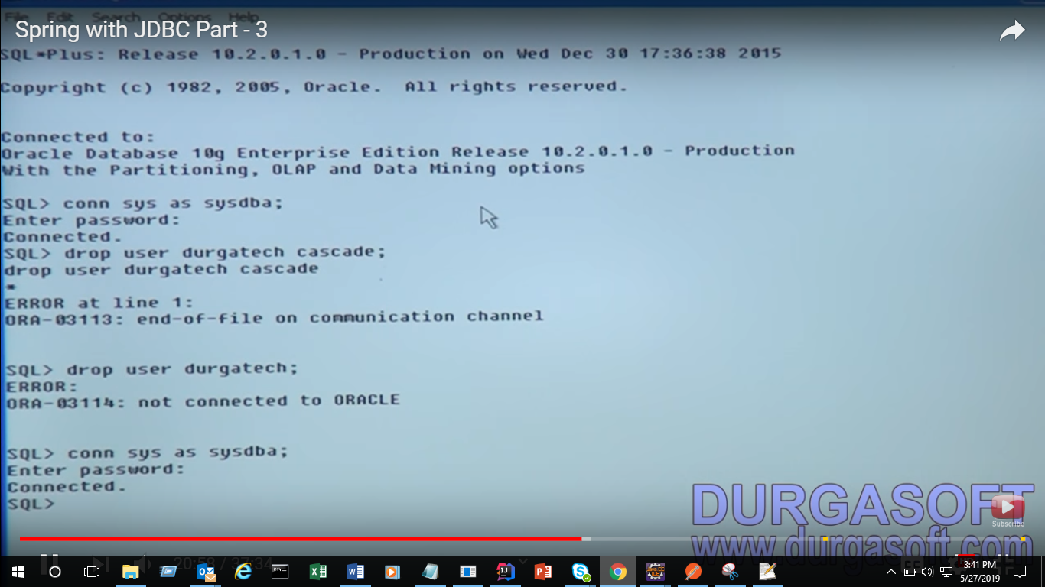

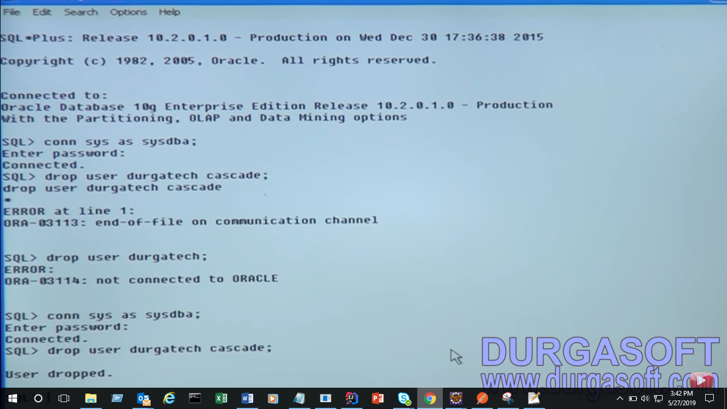

Create user durgatech identified by durgatech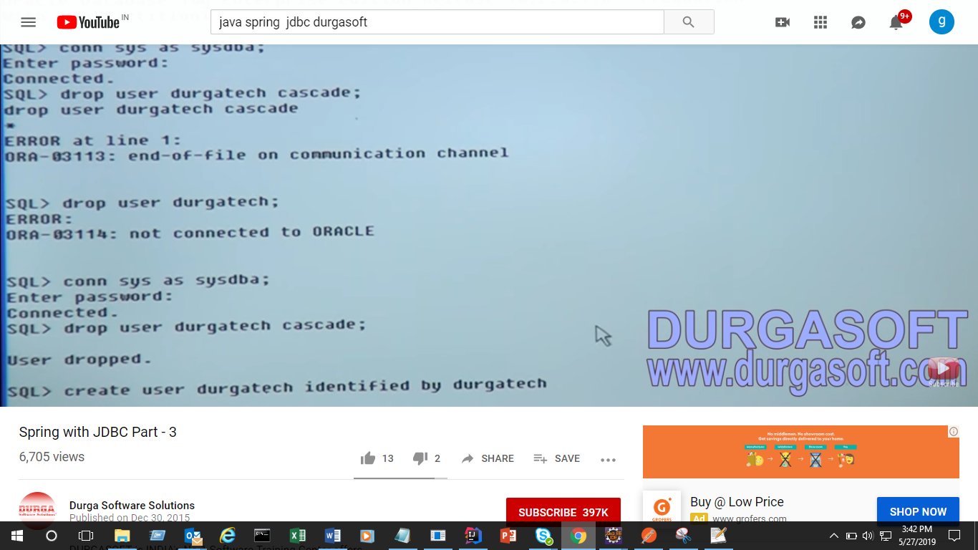

Now user is created now give grant as admin

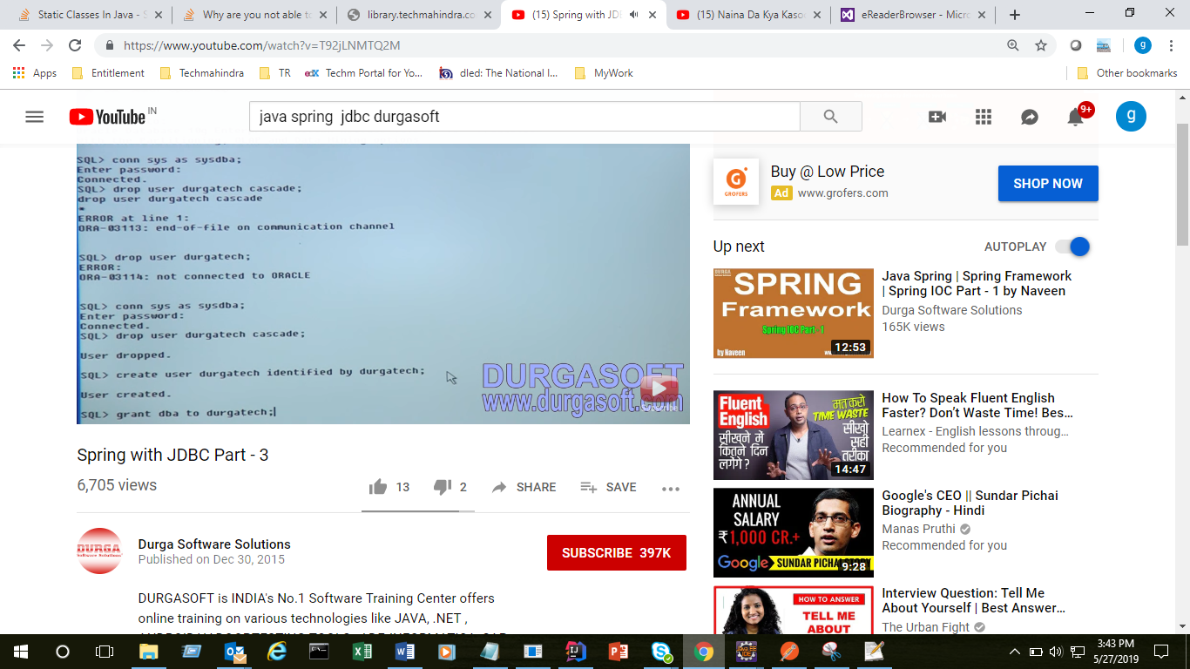

Got all permission then comit

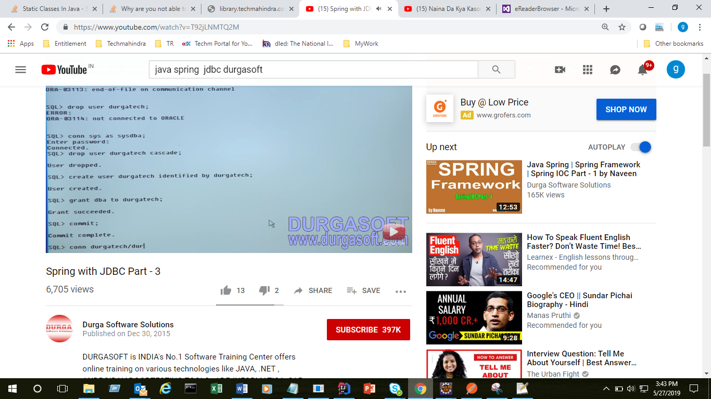

Then connect to our own schema

This real-time we have different 2 schema and different 2 users

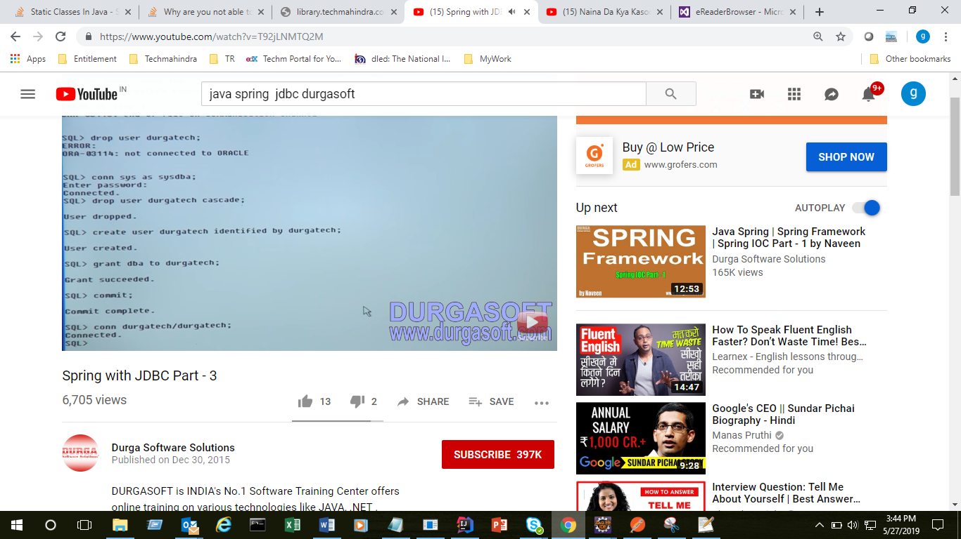

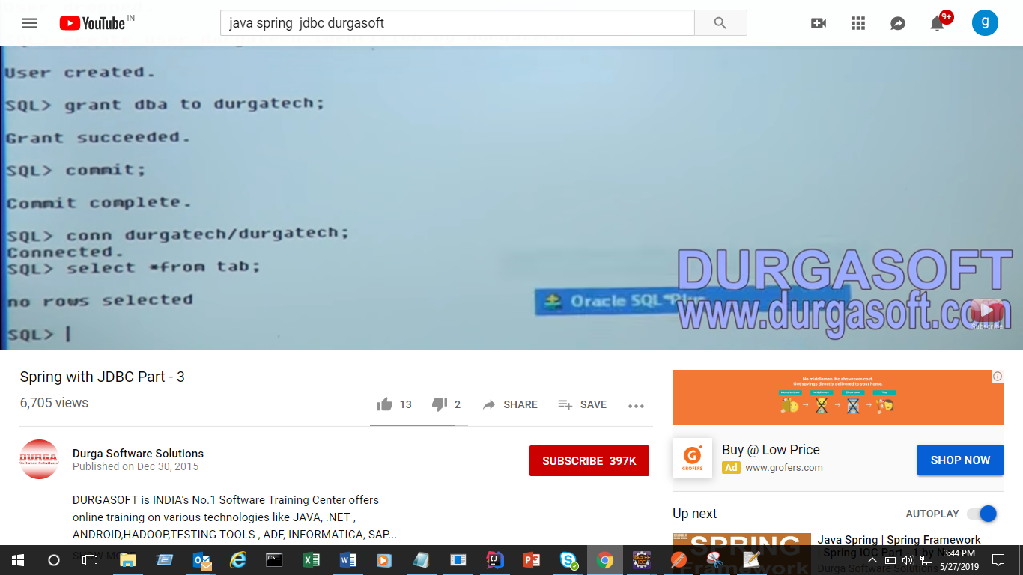

Now run our application

Got exception

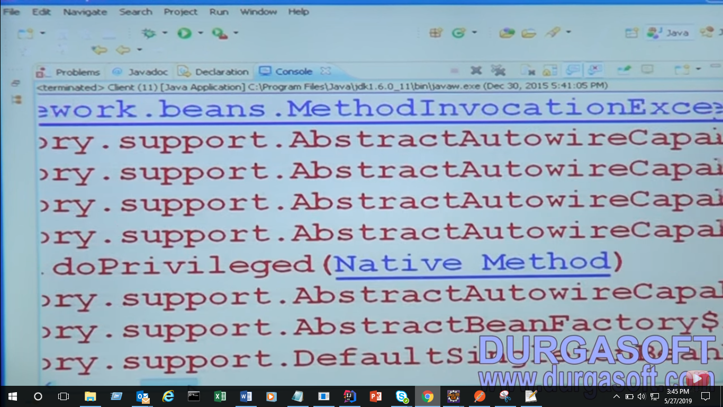

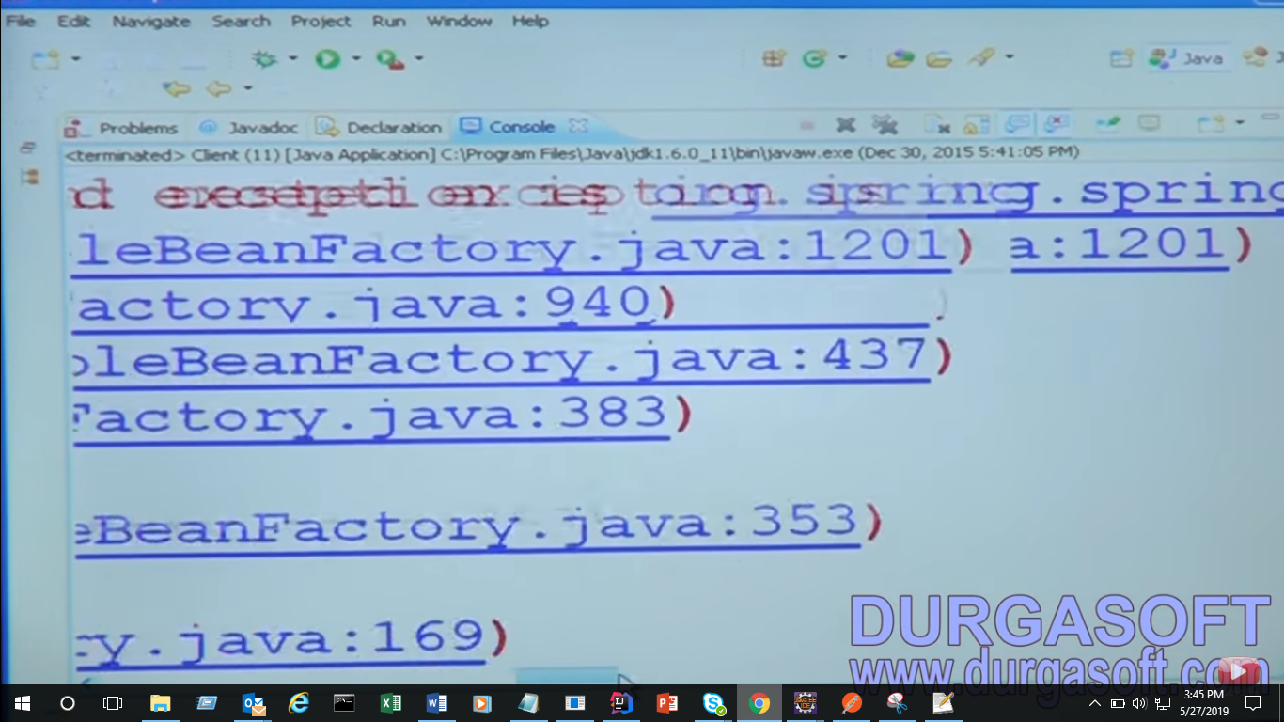

Property drive class

That mens driver is not avlable

Making avlable this driver

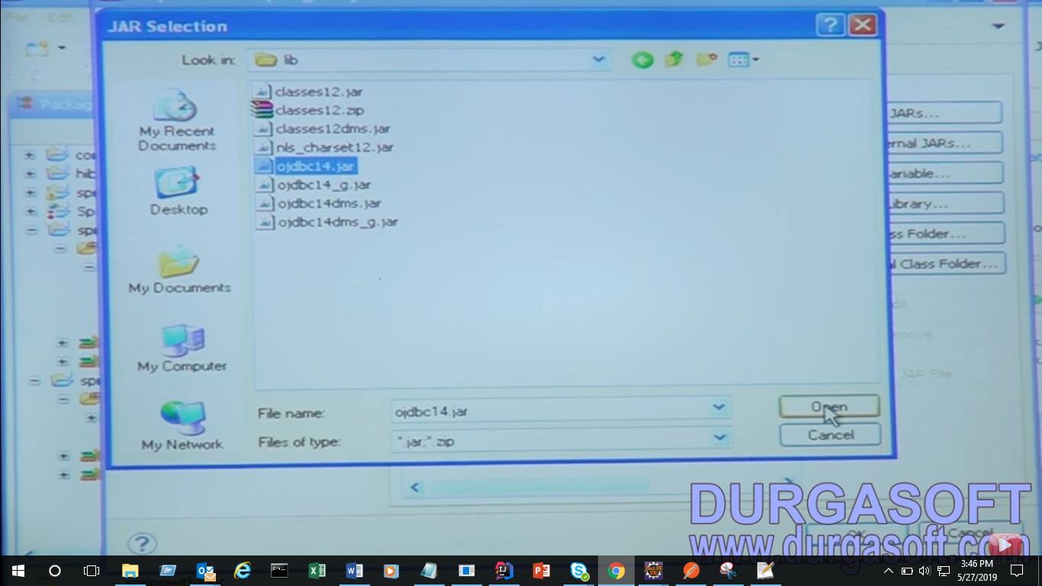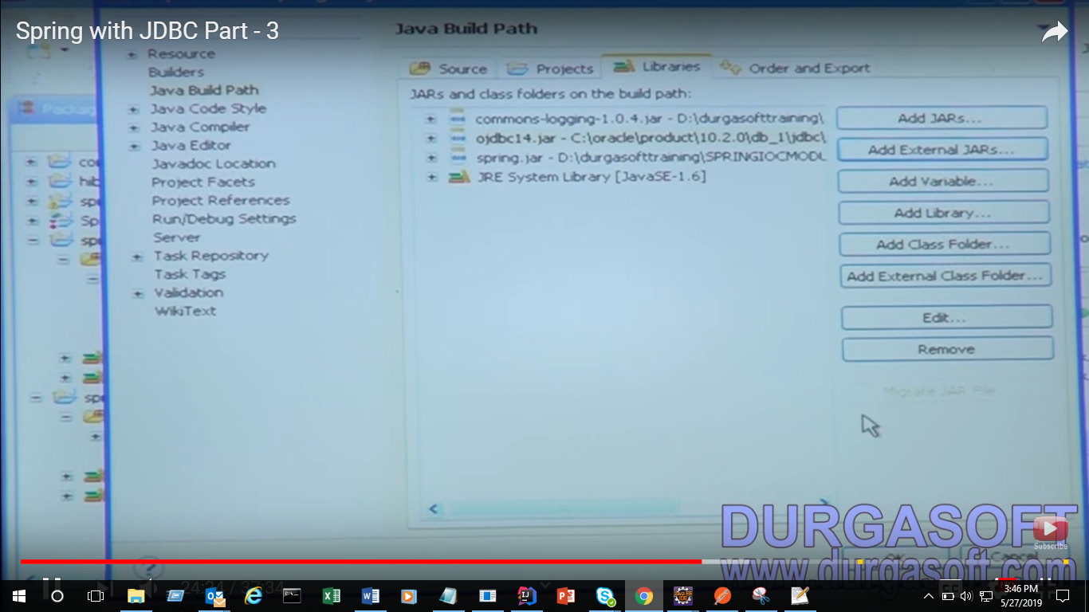

You will get it in Oracle then got product and 10.2.0 then db_1 then jdbc and chose this driver

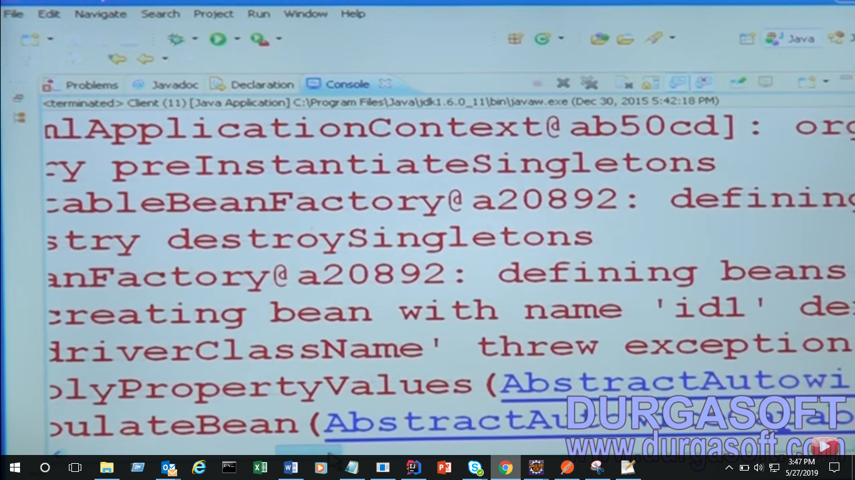

On driver class has exception

Here name is not correct

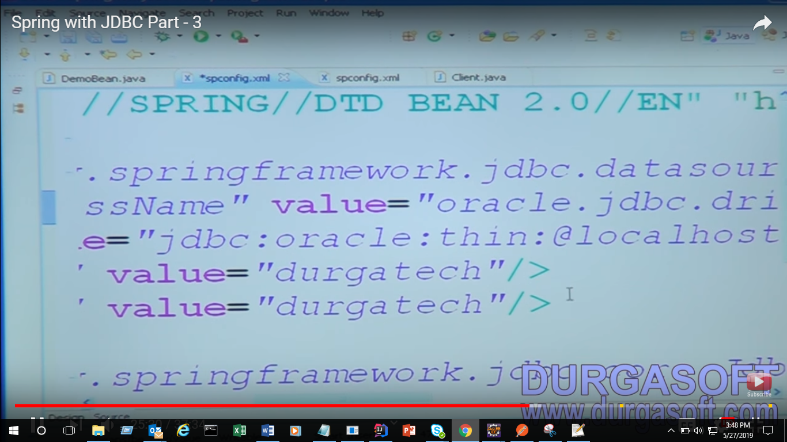

Then again get Exception :

Because of service name here showing XE now we go to sql and check what is service name

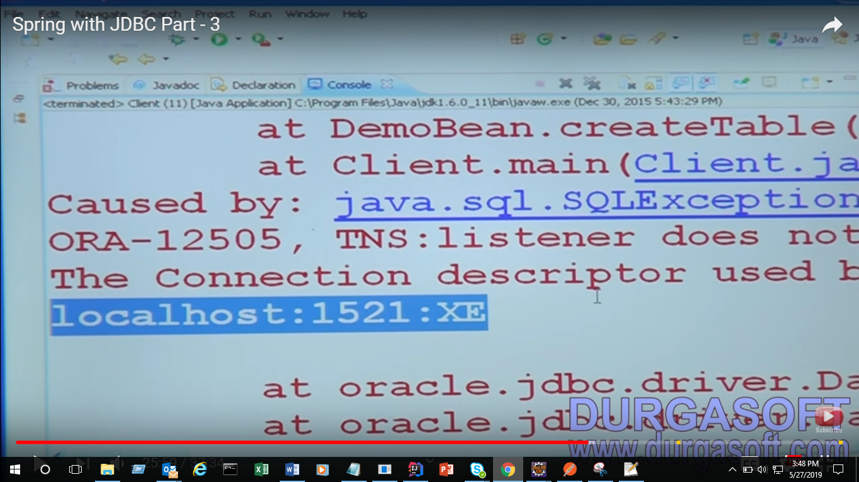

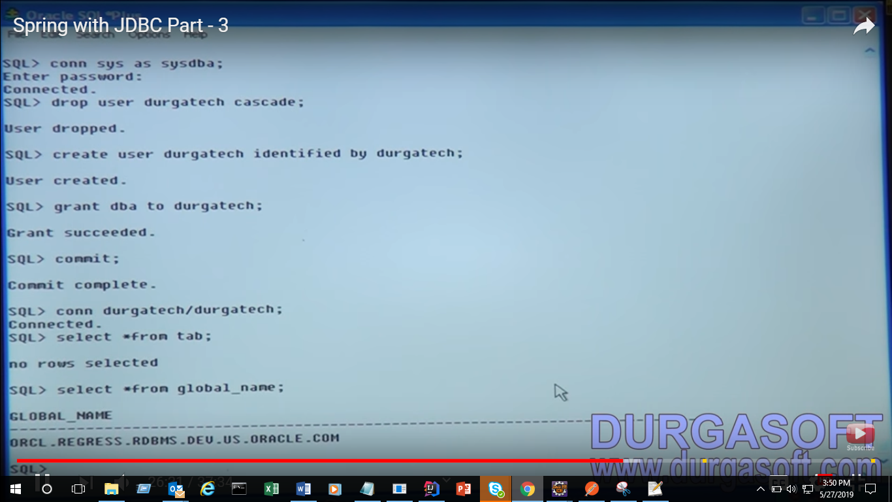

Here service Id : ORCL

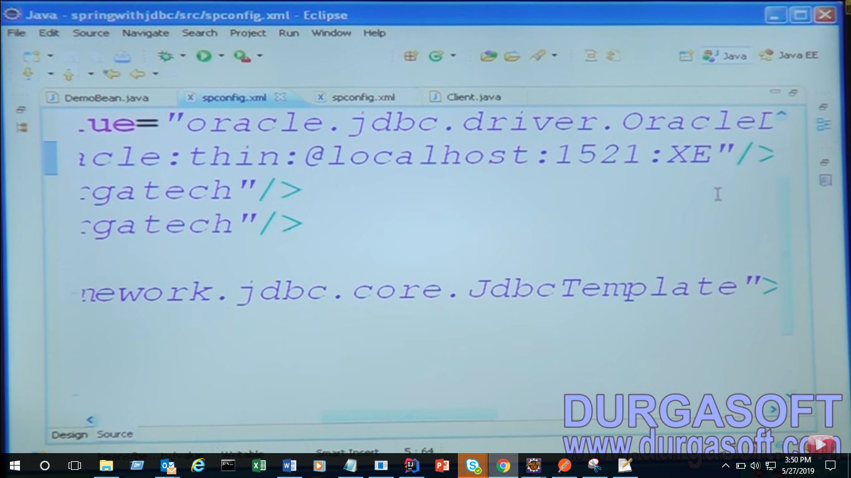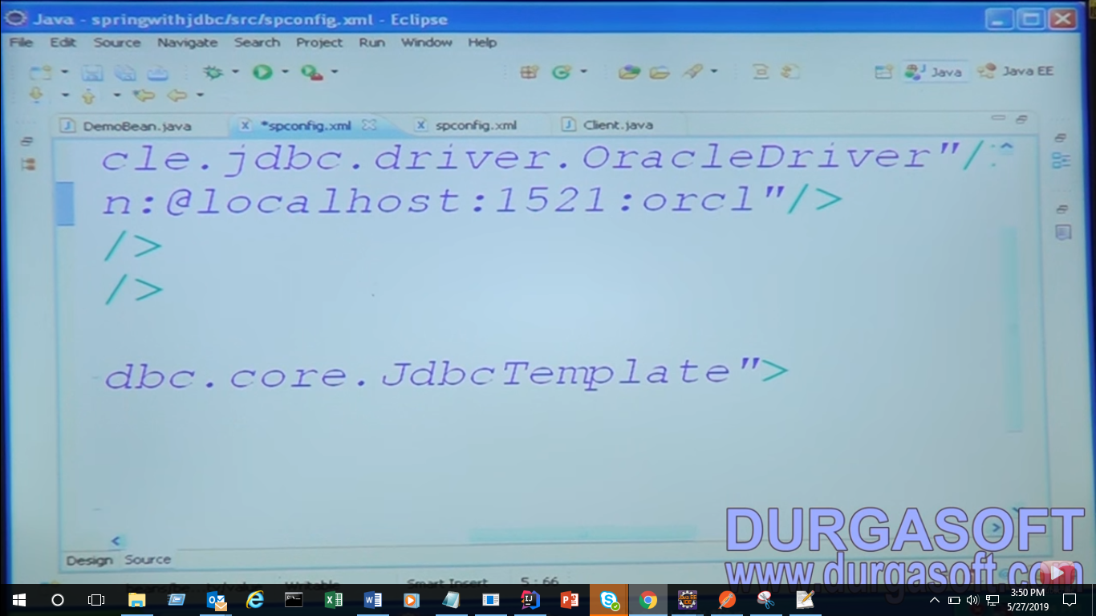

We have XC – express edisition

And ORCL

Agin get error

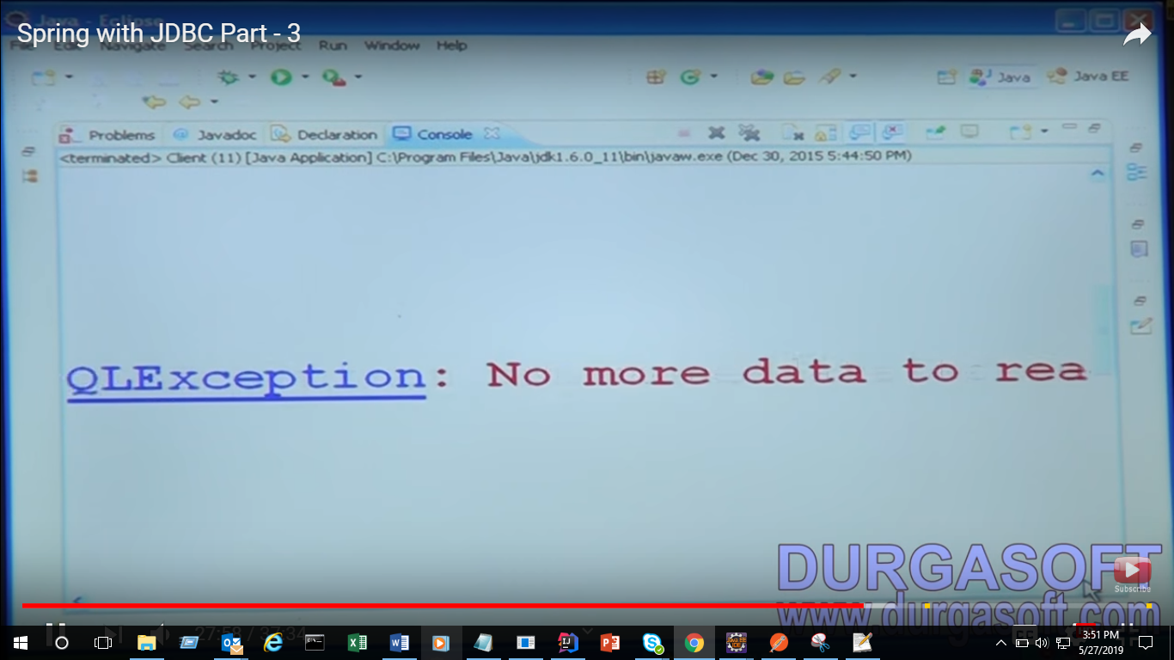

This look like its problem of oracle server now need to restart

Go to services

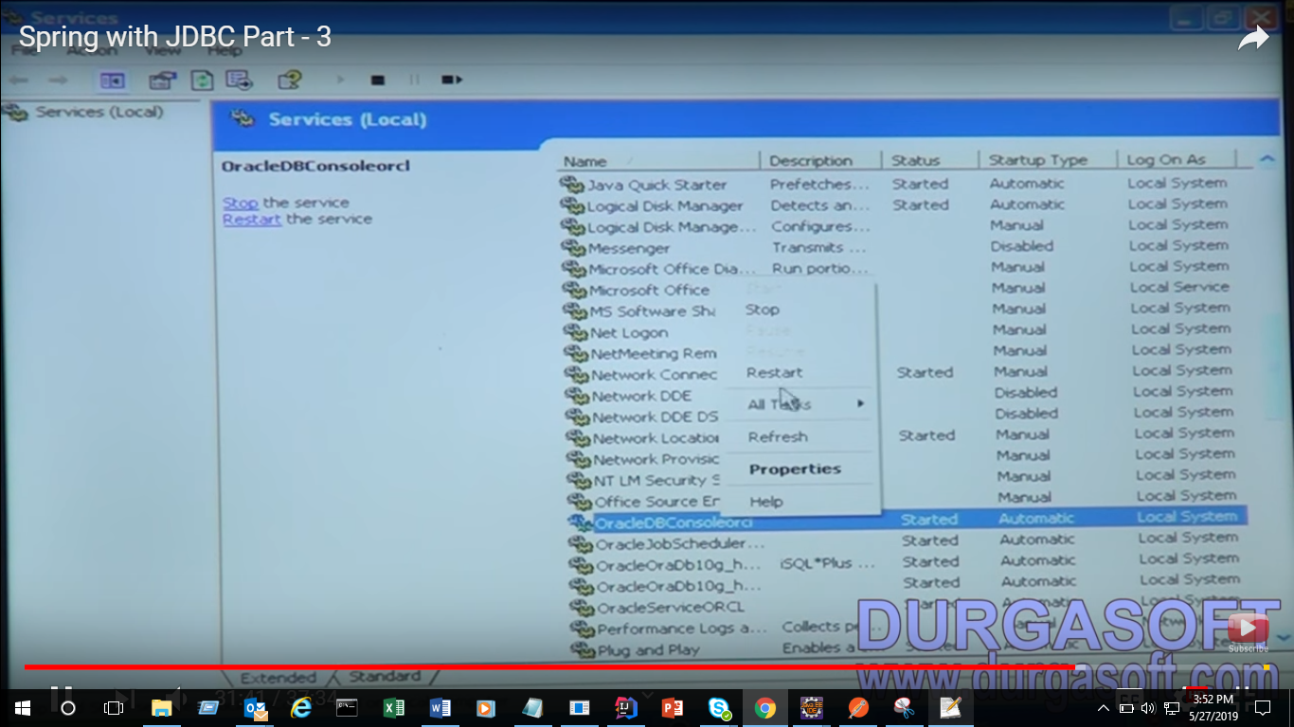

Start this OracleDBConsolecli

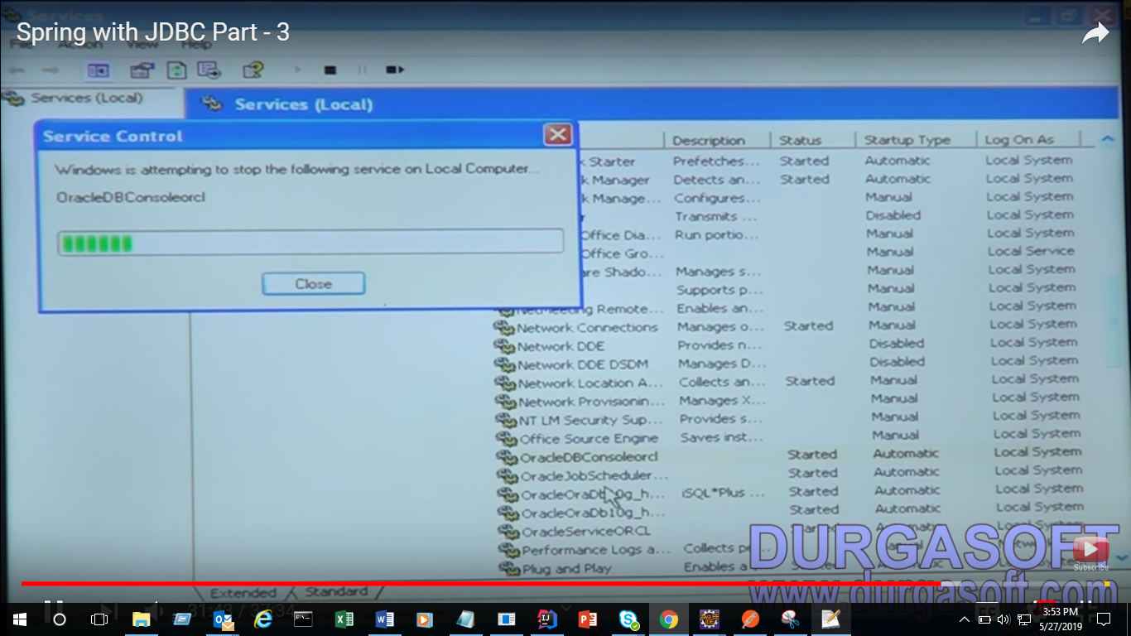

Reatart all realted

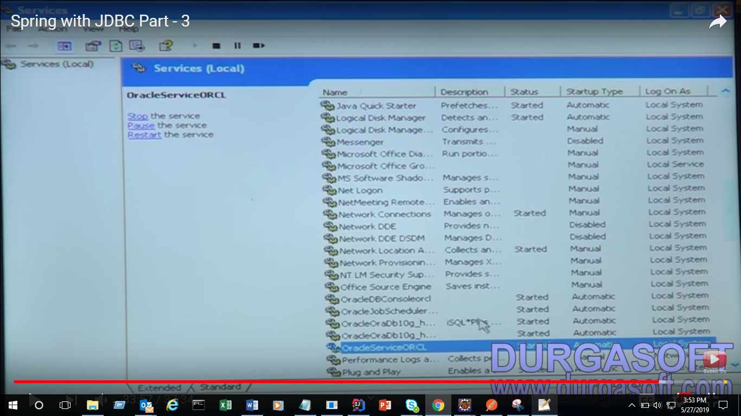

Now connect

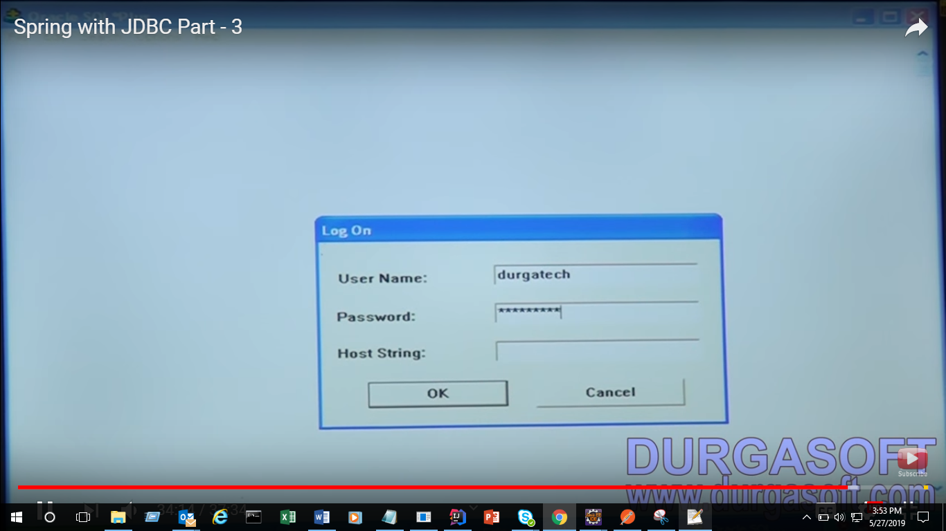

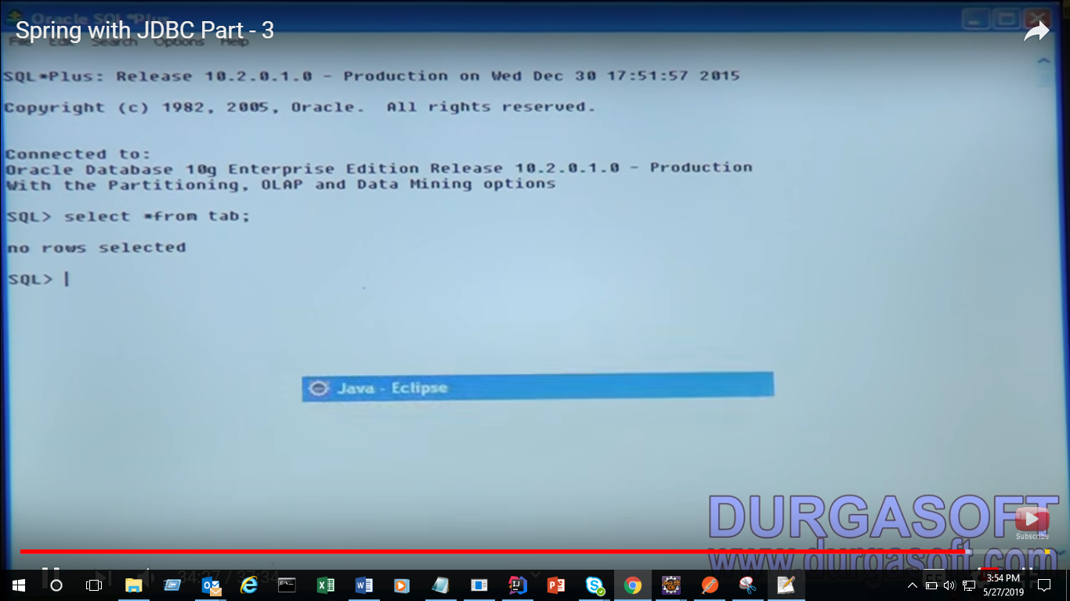

Now run application

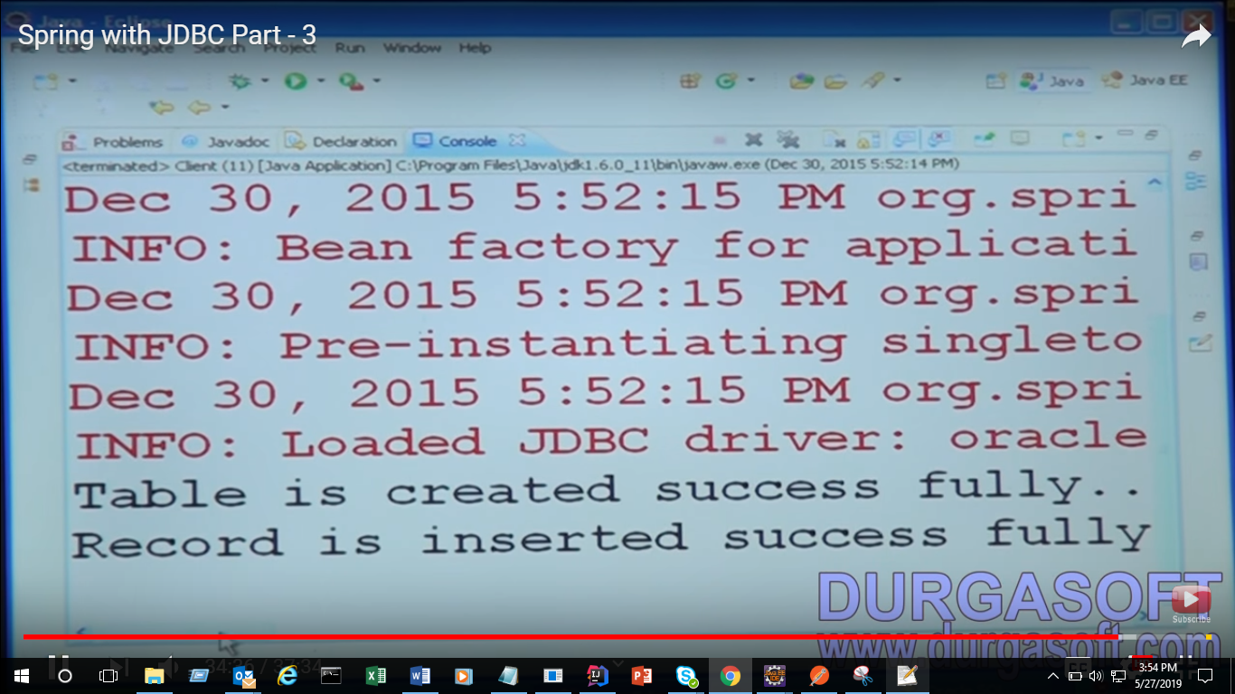

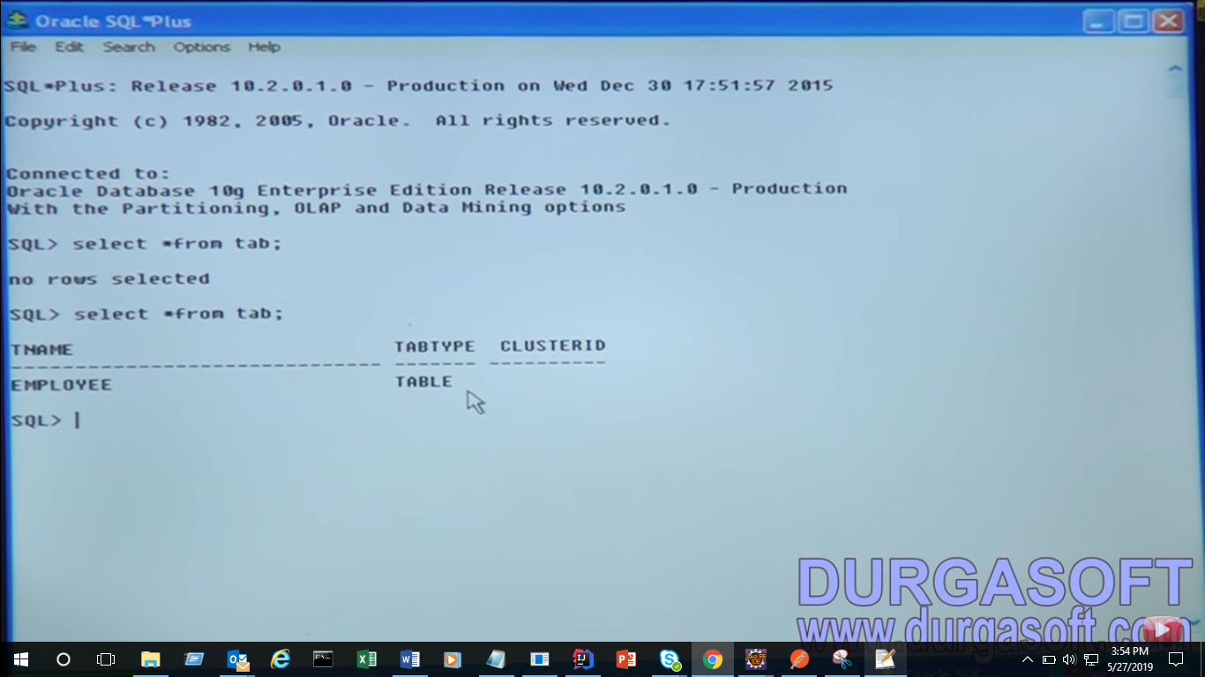

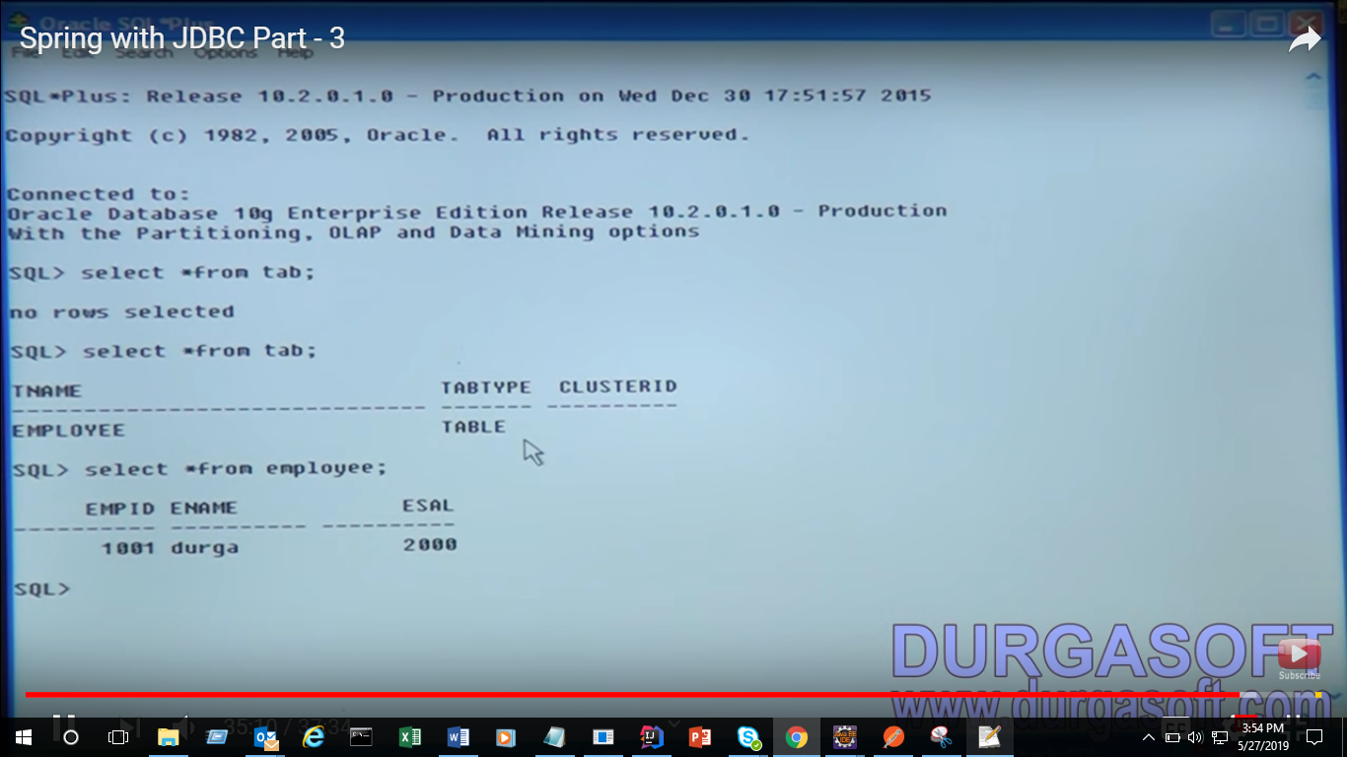

This current approach is not good practice Business logic should not mix with persistence logic

If you see in this createTable() method is Business logic and jt.excute() is persistence logic

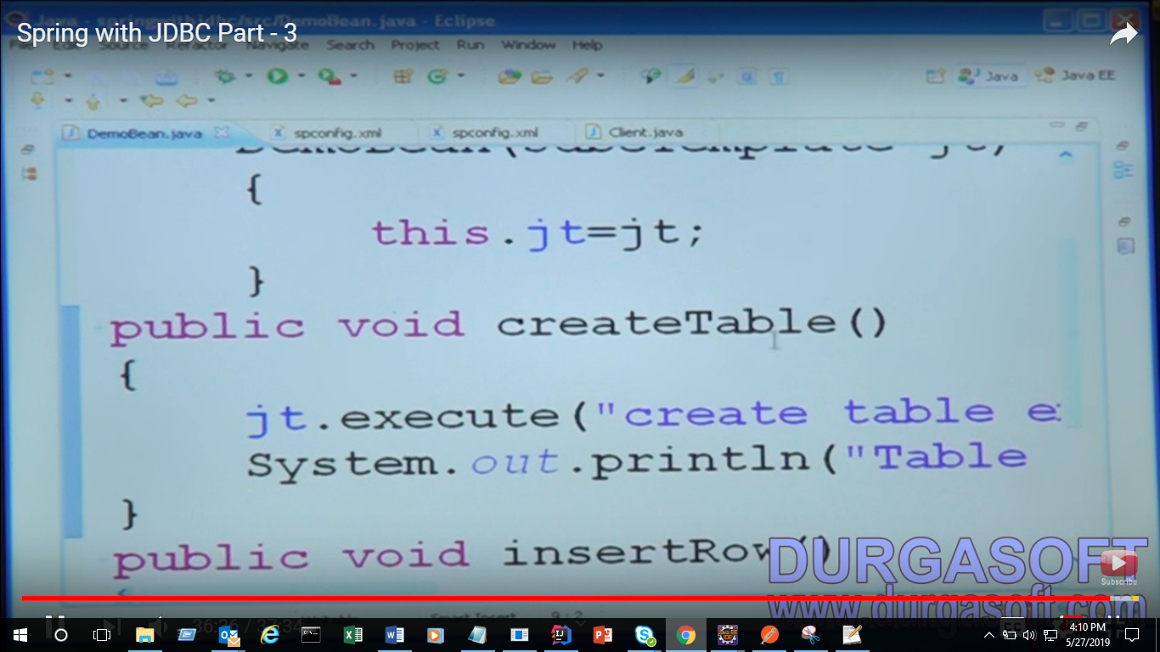

We will separate both the component so in future if we do some changes it will not impact to each other

Spring with JDBC Part – 4

<https://youtu.be/nZyeb4iKawQ>

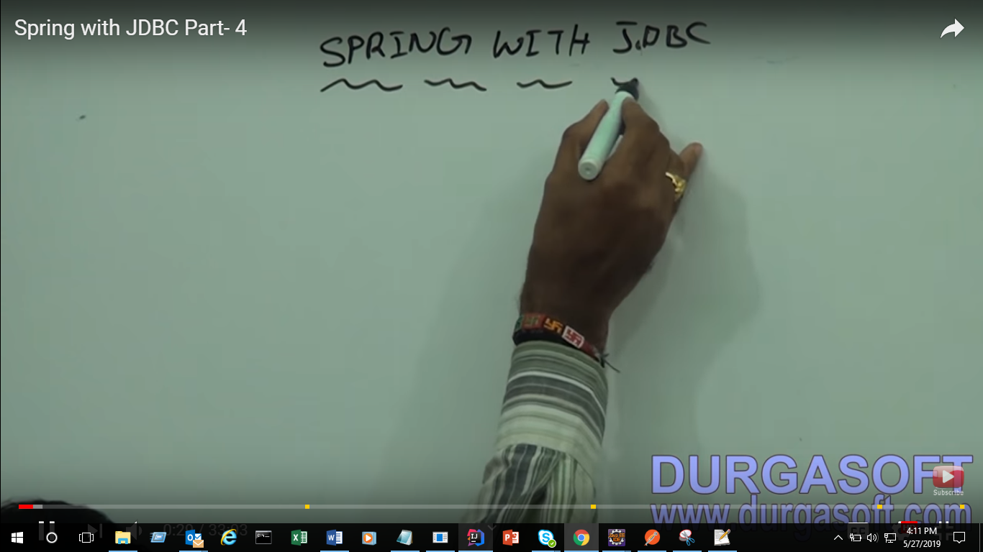

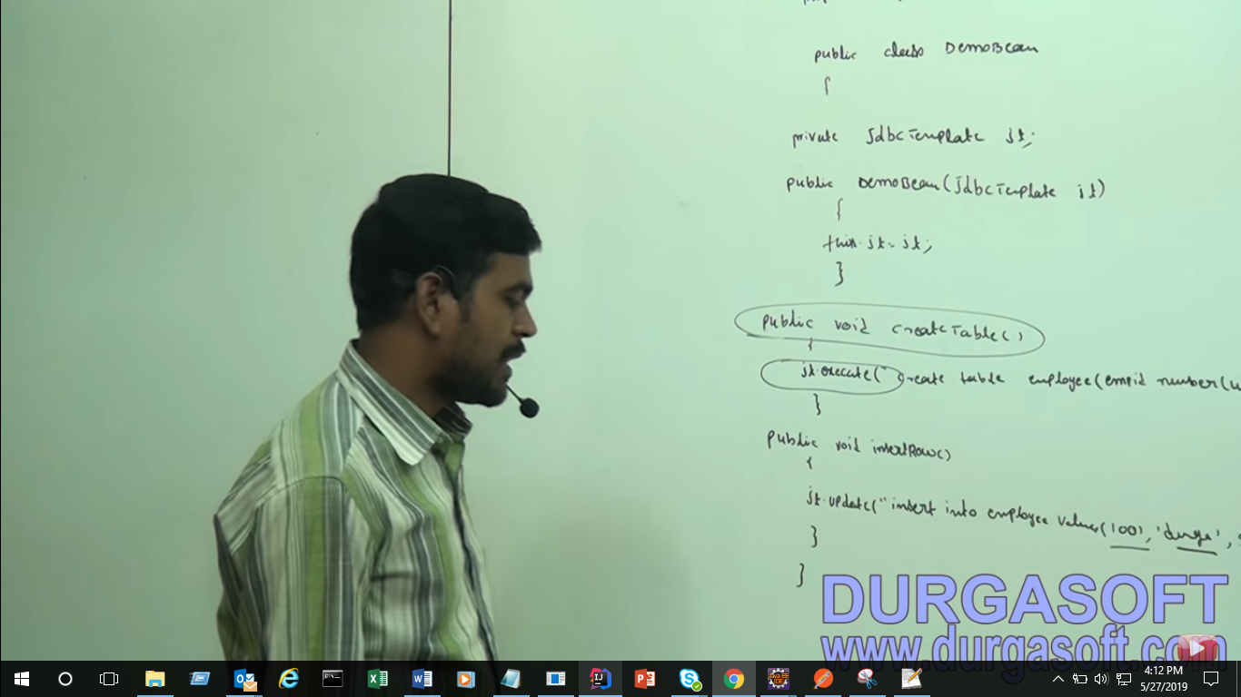

We will separate both component

Below Ex of both business logic separate from persistence logic

Taking As interface

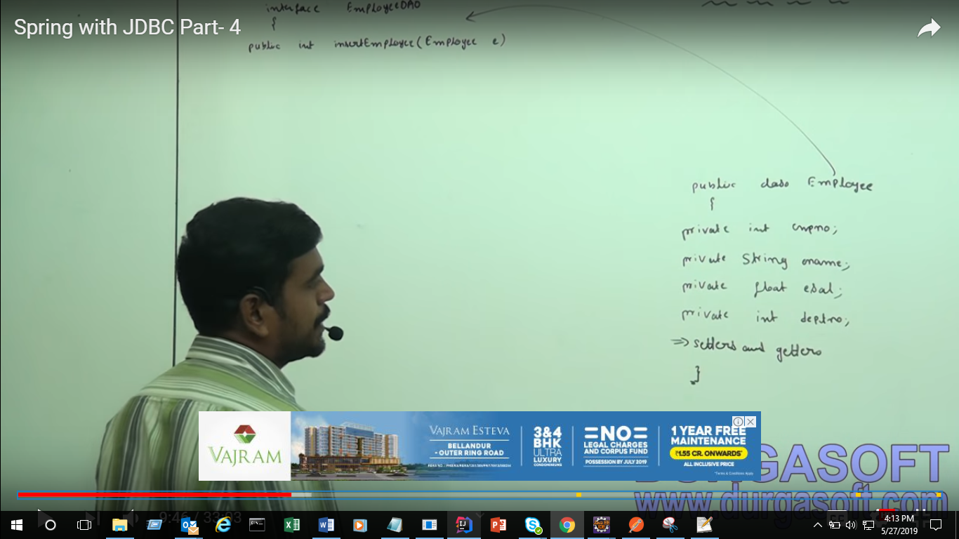

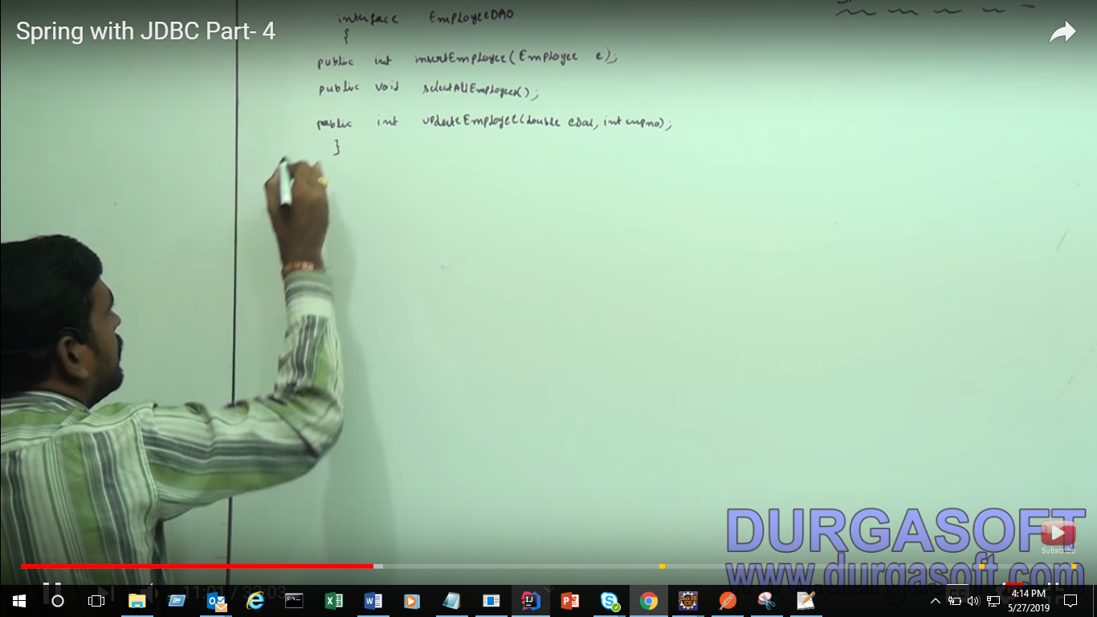

Why we created interface here there is many advantage and will get benefit of inheritance

We can take as reference Interface class name and private Emloyeedao dao;

Through this we can call child class of method of this interface in future if some body will change class name also there we can able to call from interface reference and also in future if some body can create n no of deoImpl we can easily call with this reference without any change this beauty of inherence and Interface

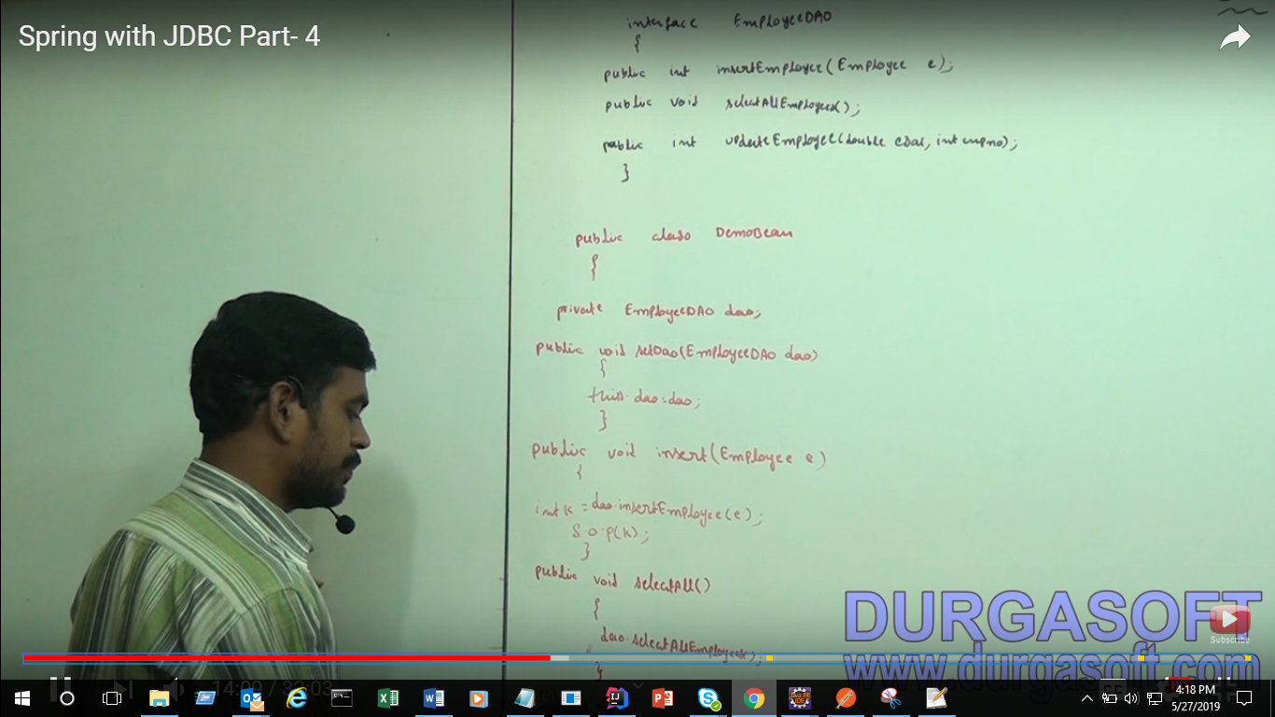

Demo bean we call its as BO layer

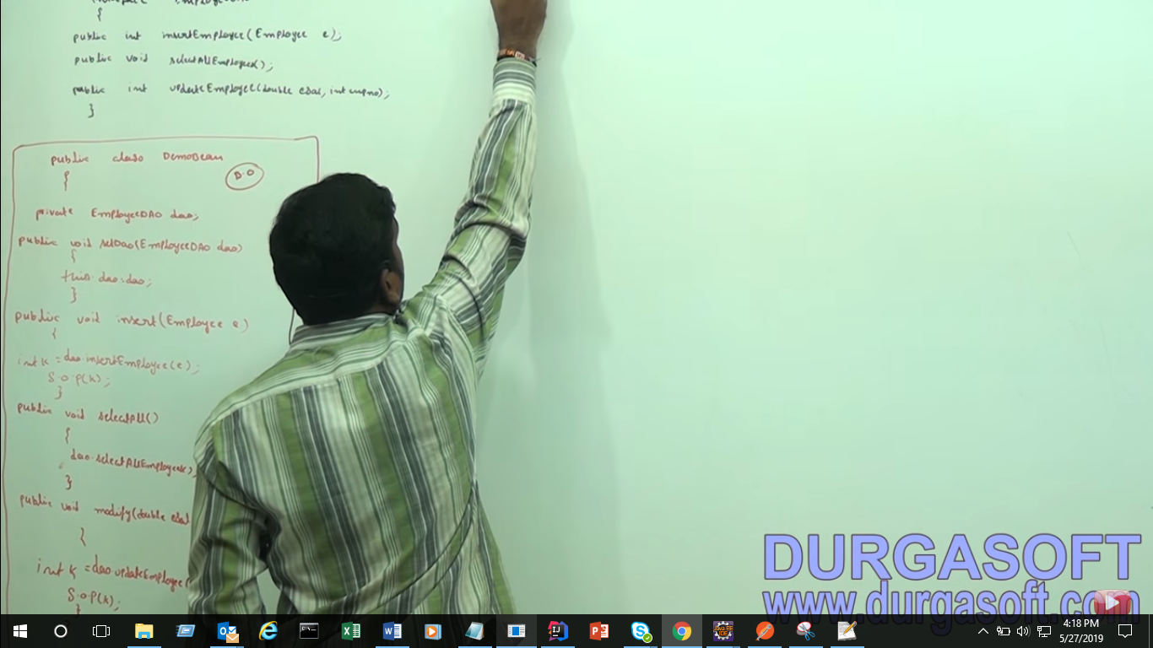

Creating Impl class

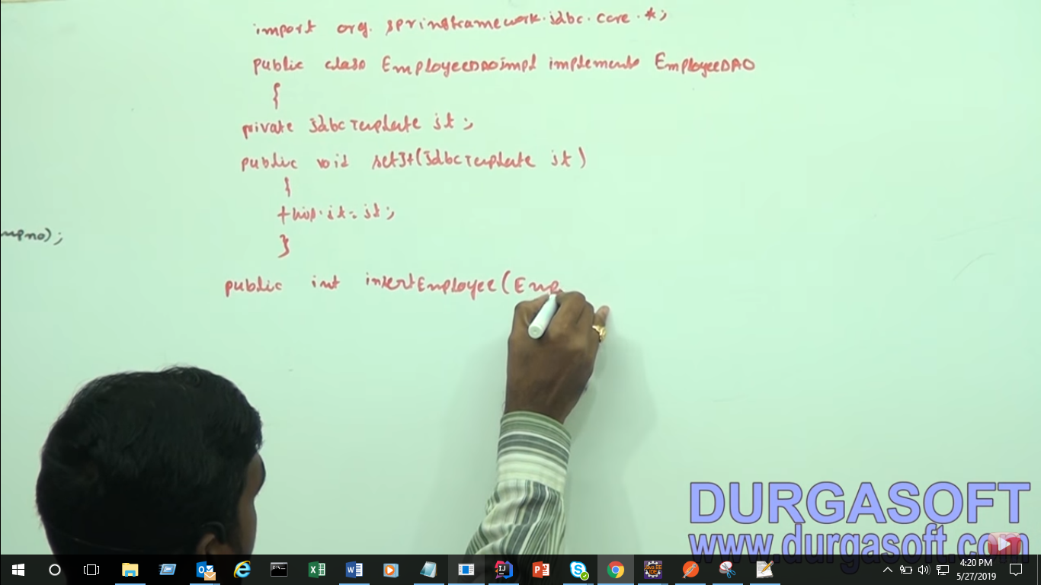

Now we are doing in JDBC

Though preparestatement

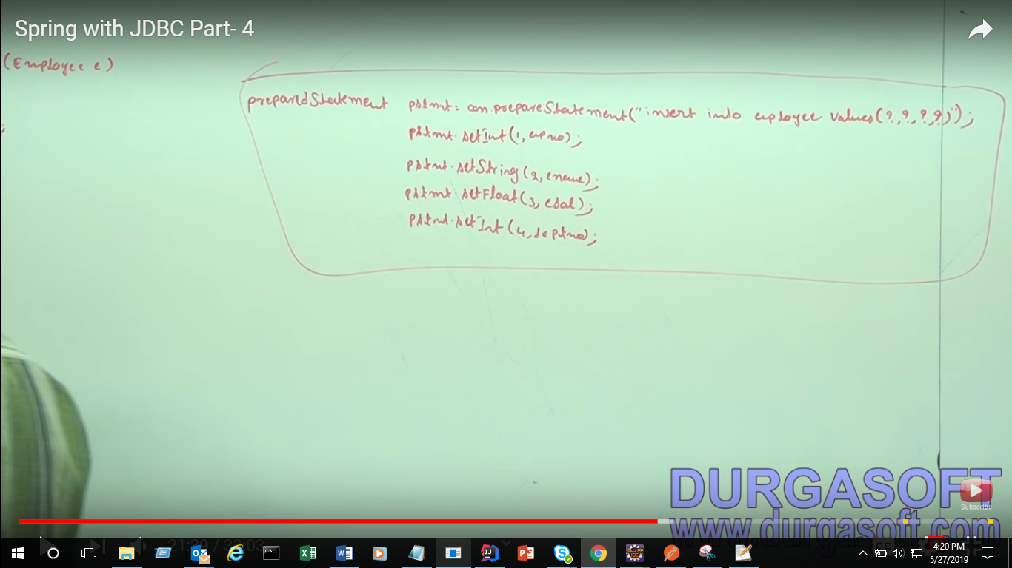

Now what we will do in Spring JDBC through param

This we using for insertion in DB

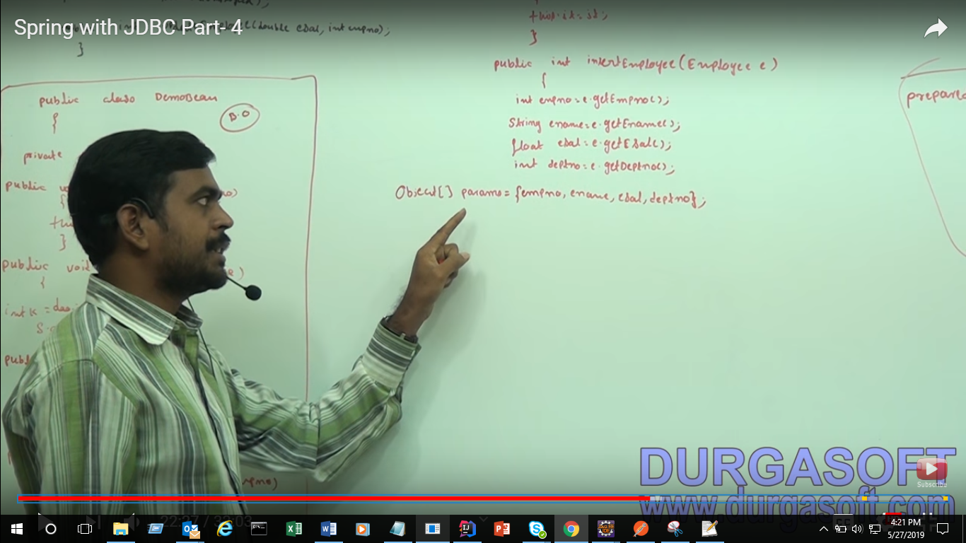

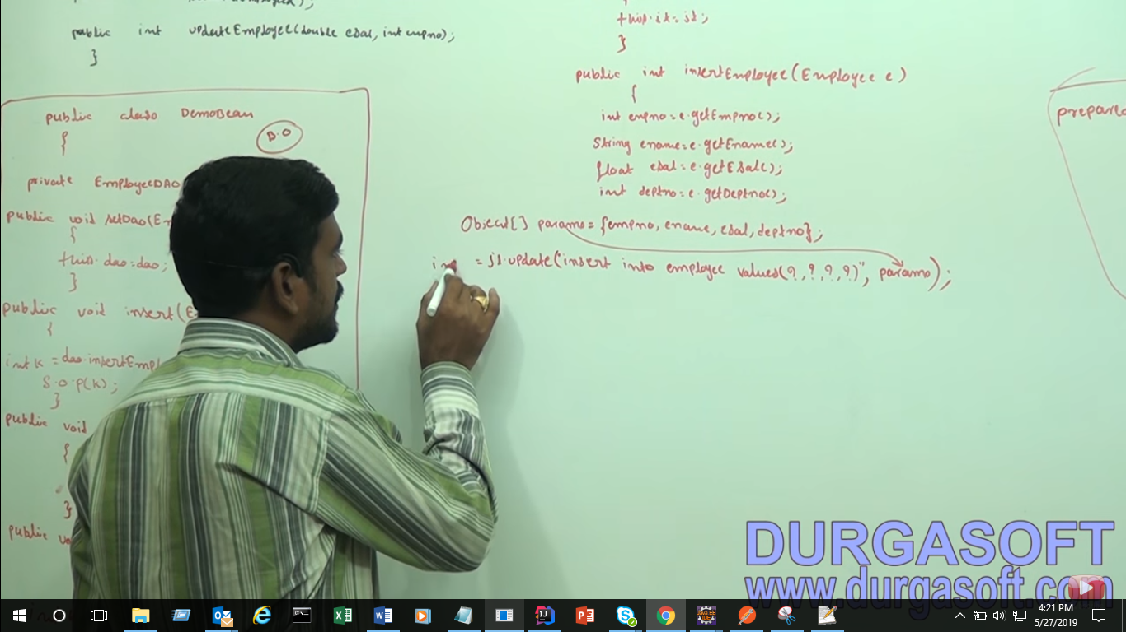

This fetching/updating the records

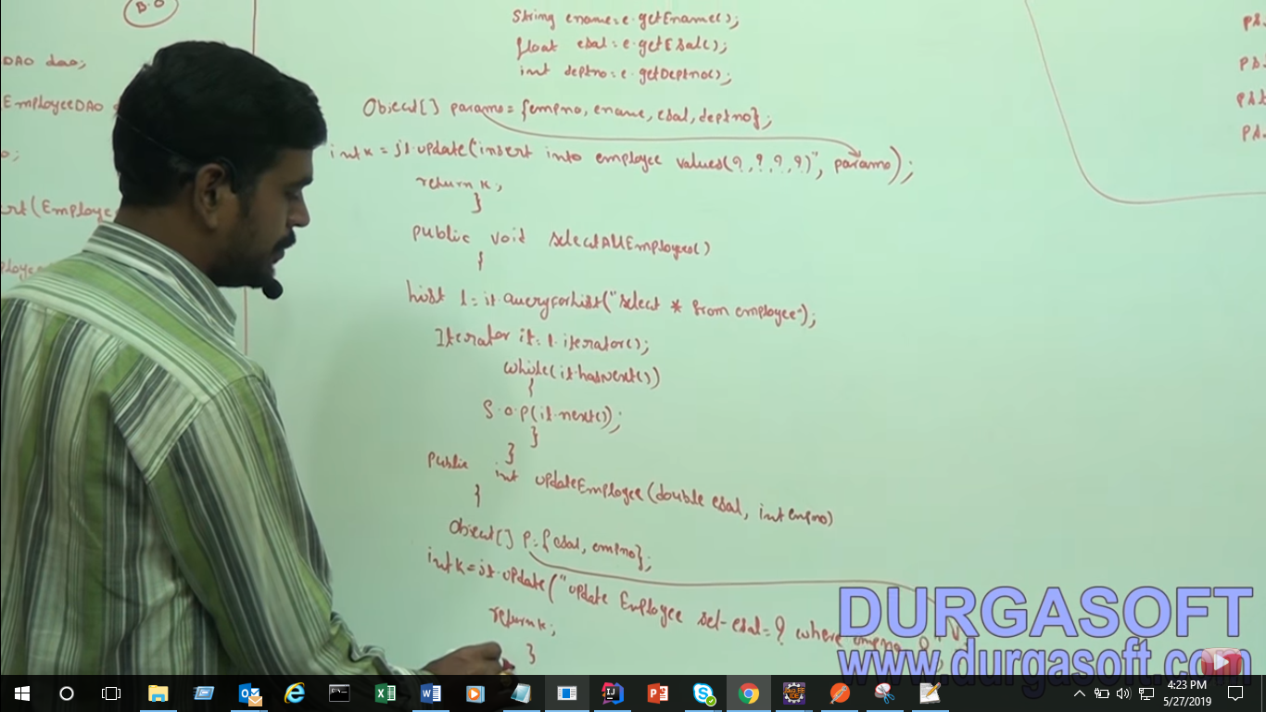

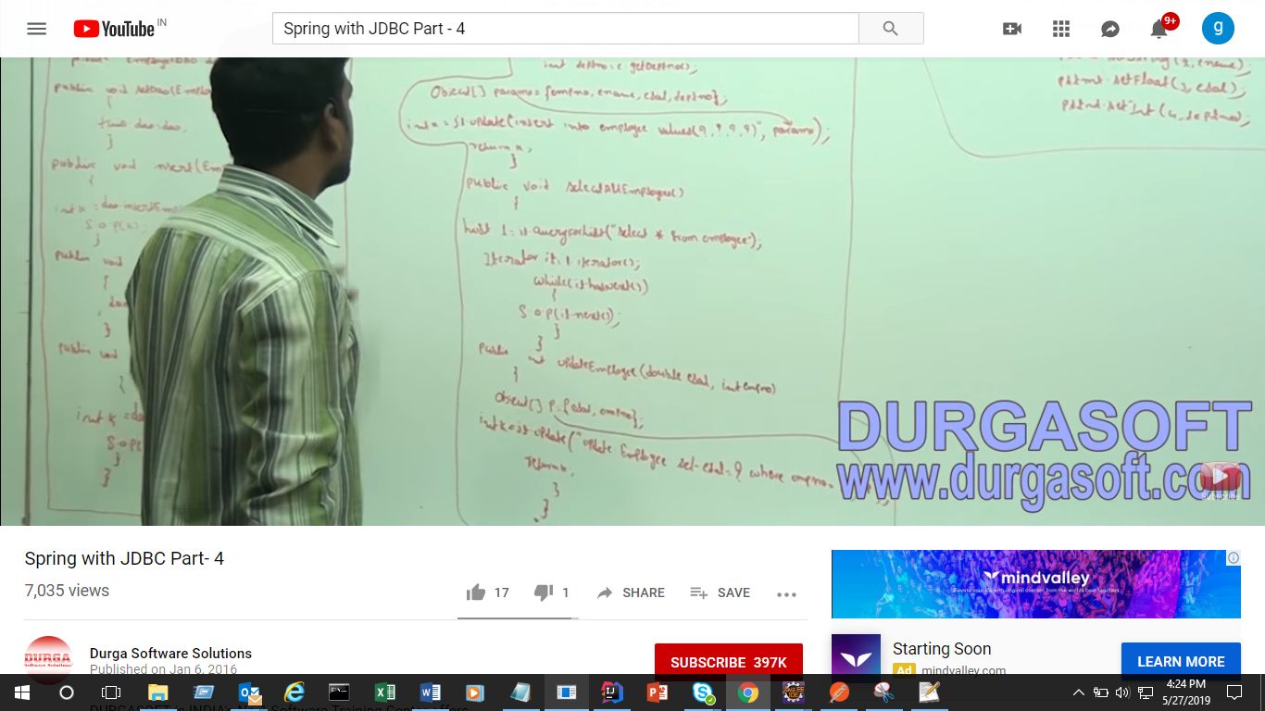

In this pic can see BO and DEO(persitance layer)

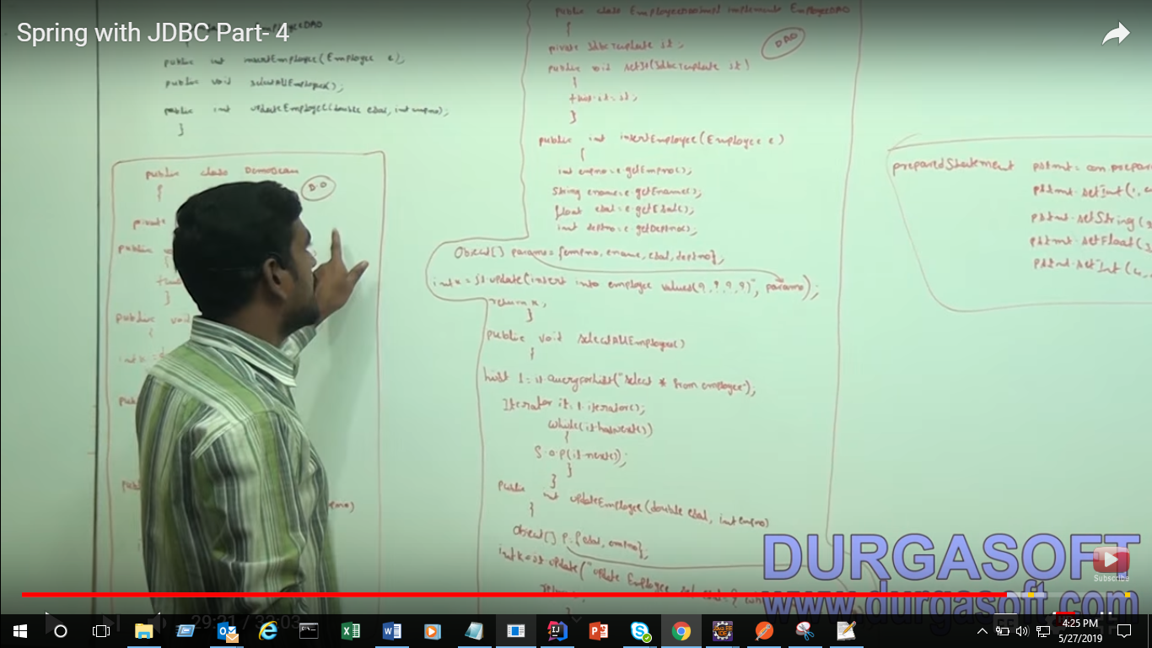

How many class we need to configure?

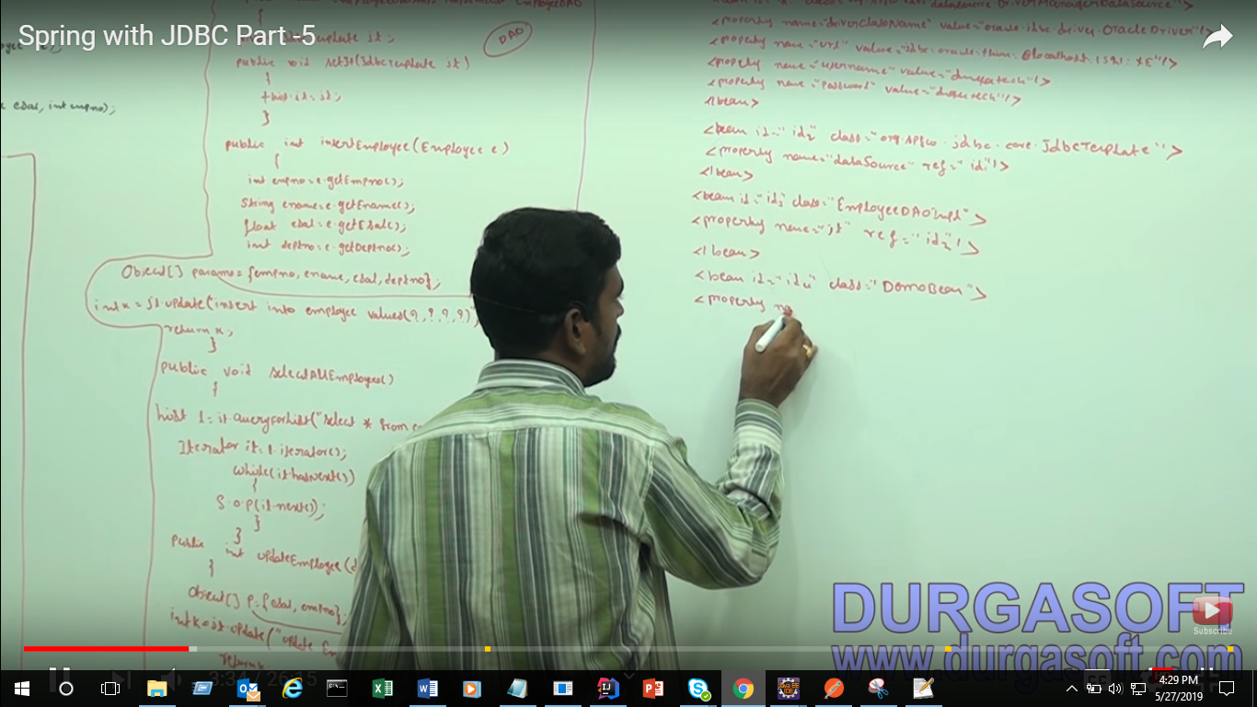

1. DriverMangerDataSource
2. JDBCTemplate
3. EmployeeDeoImpl
4. DempBean

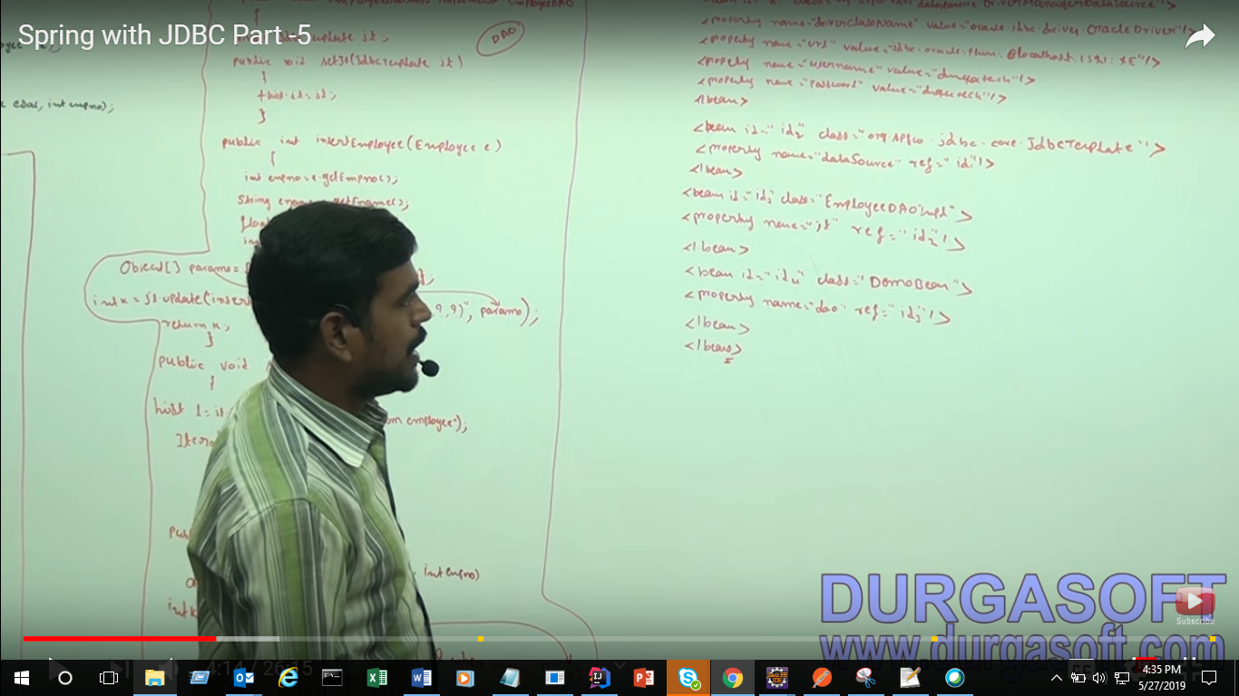

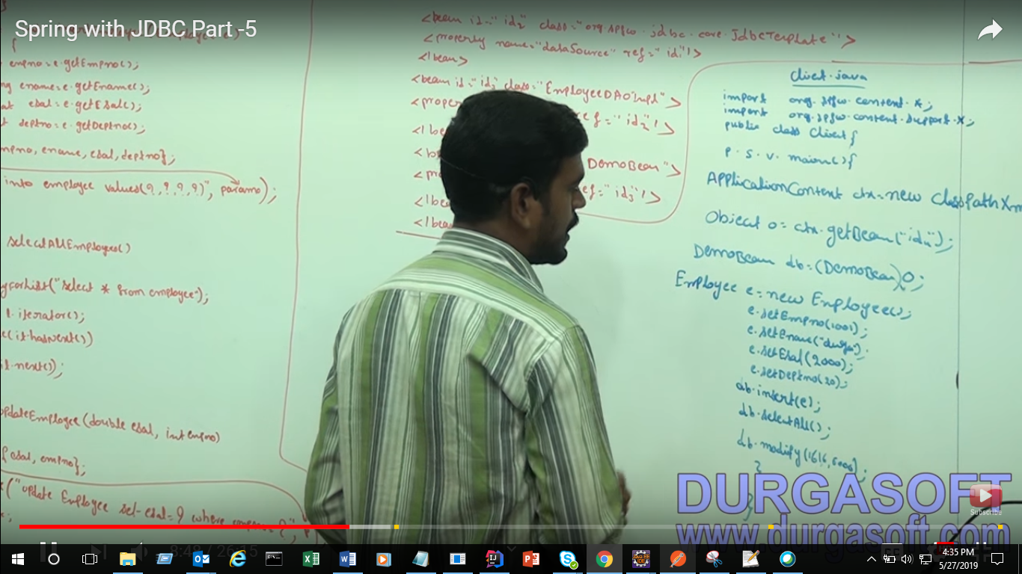

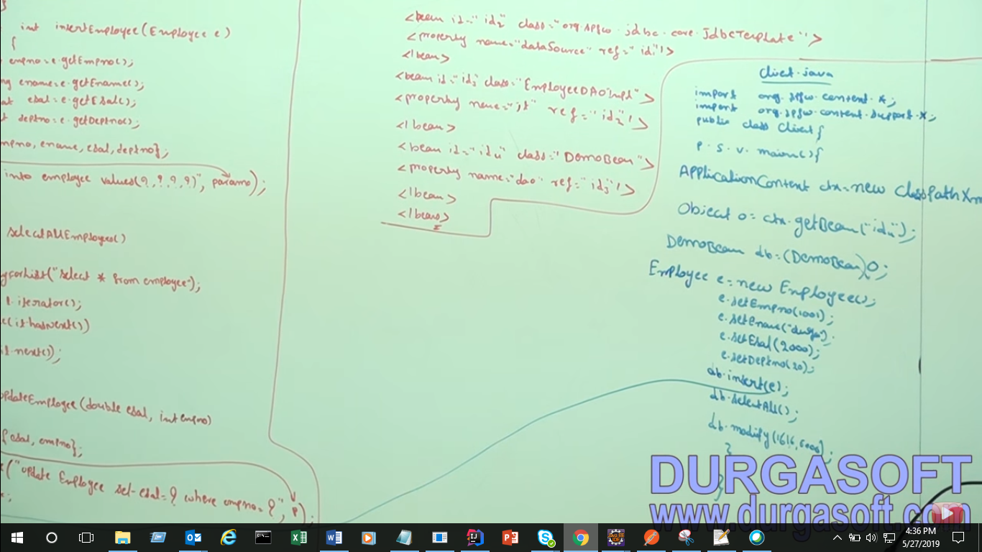

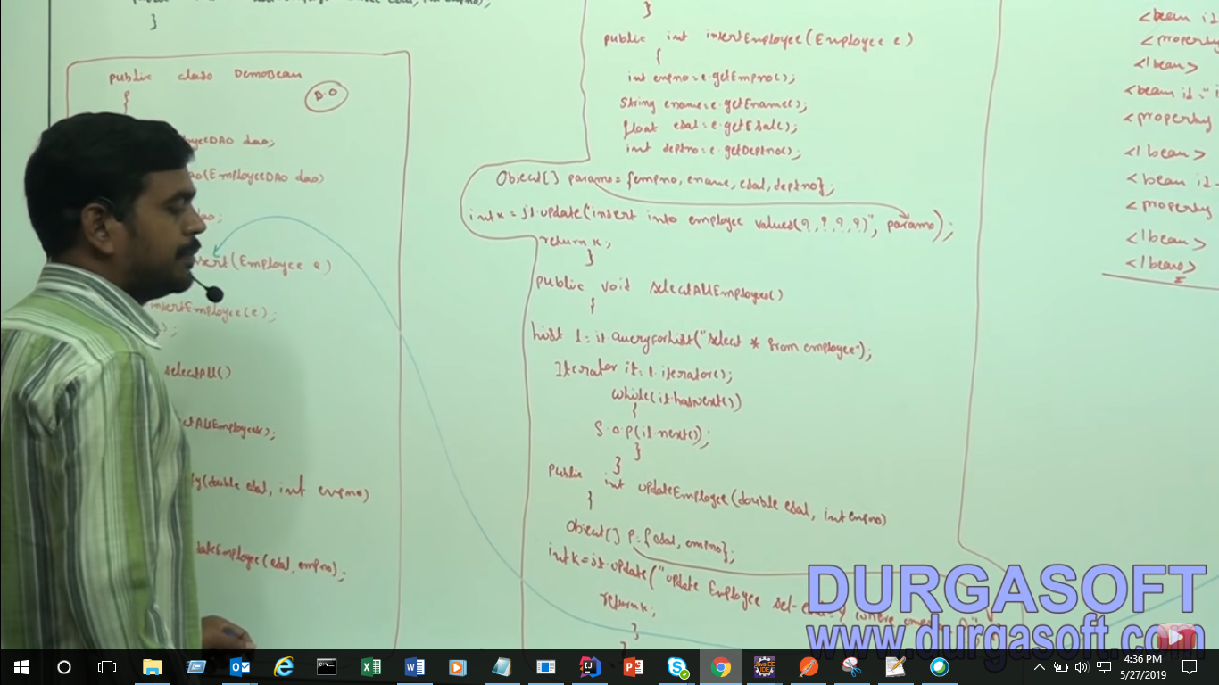

Client.java

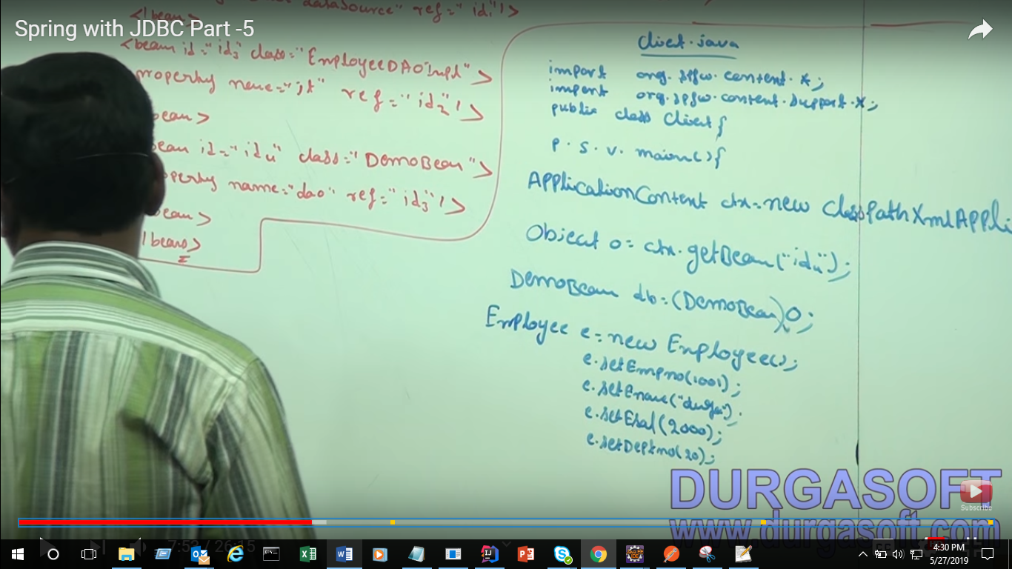

Call process :

First BO method call

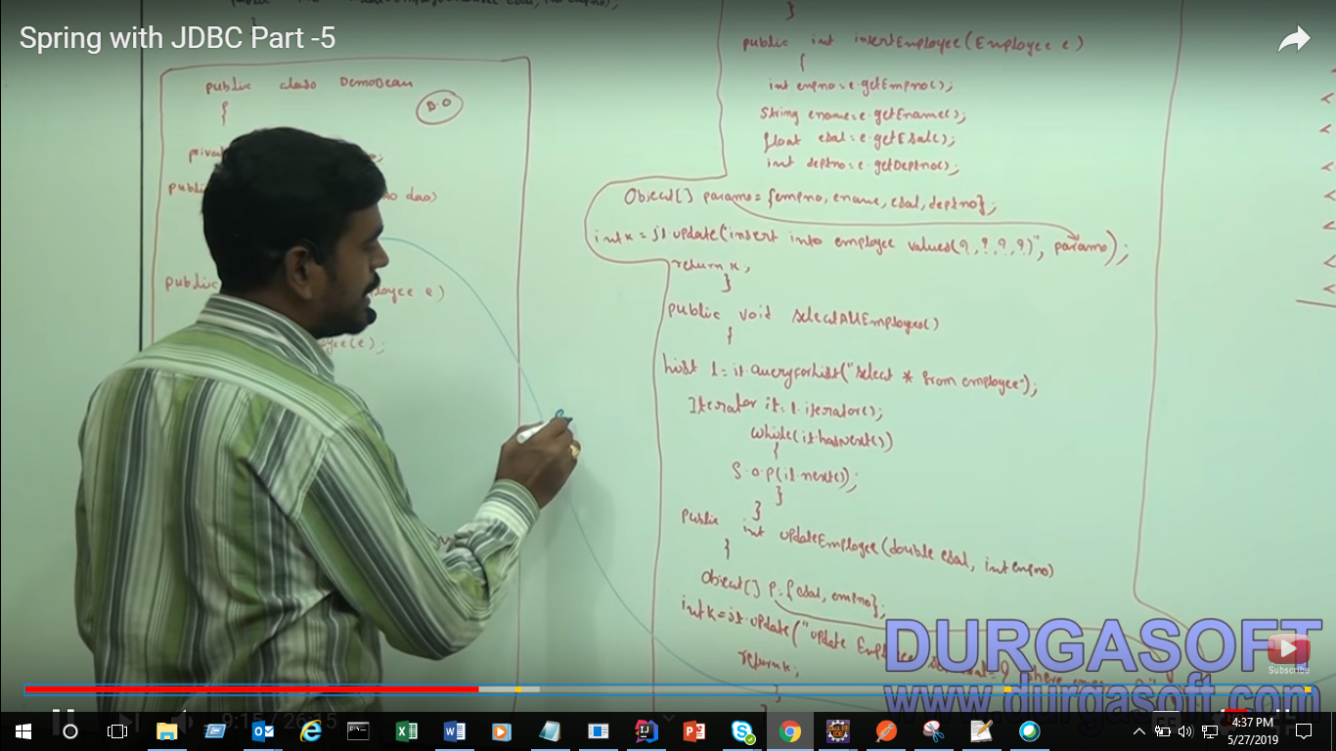

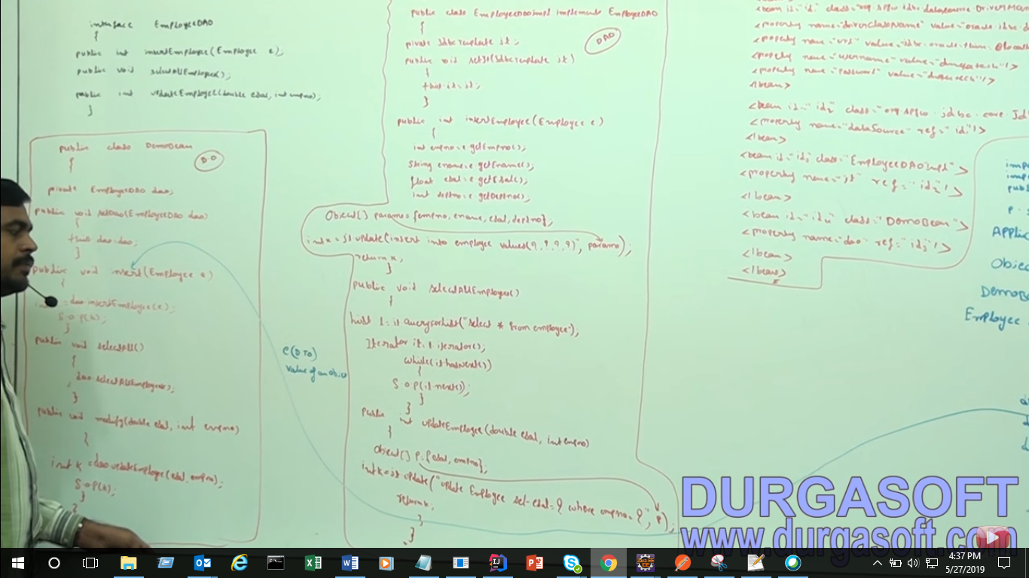

That e object is DTO value for an object

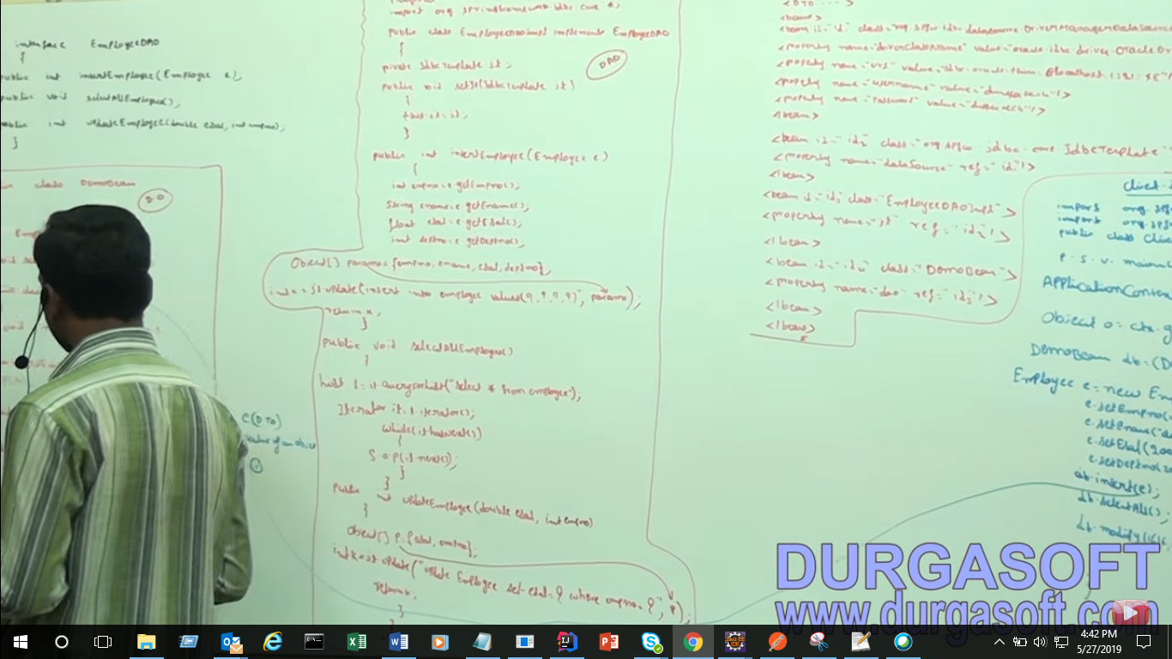

Step 2 this method is going to verfy whether this method hpresent in interface or not

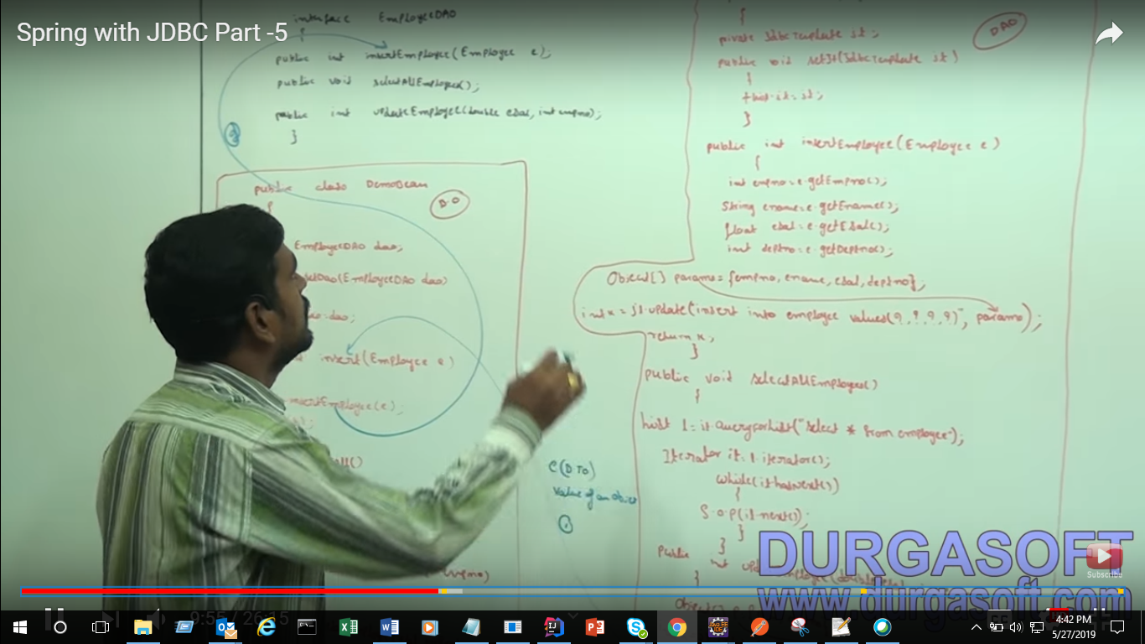

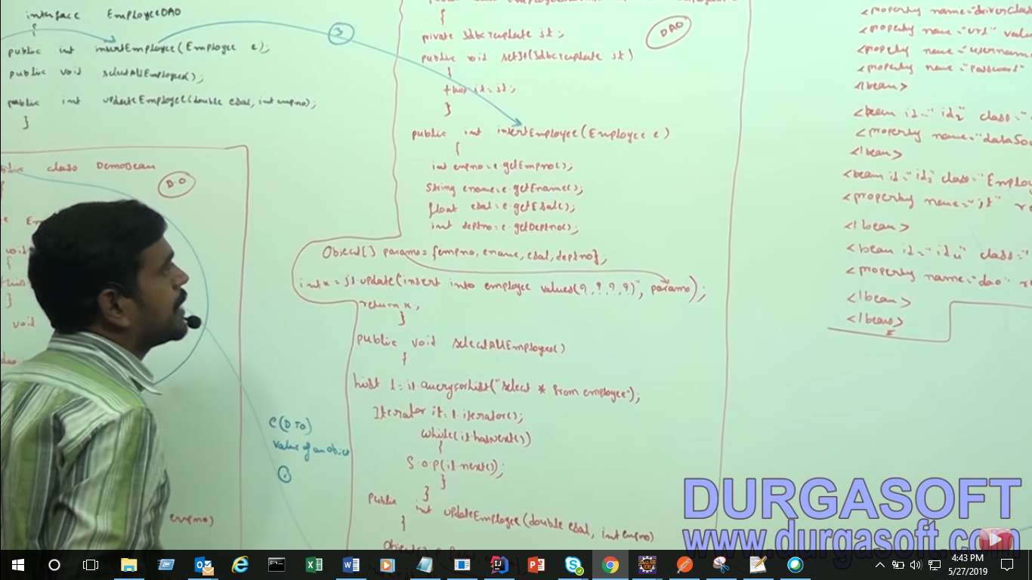

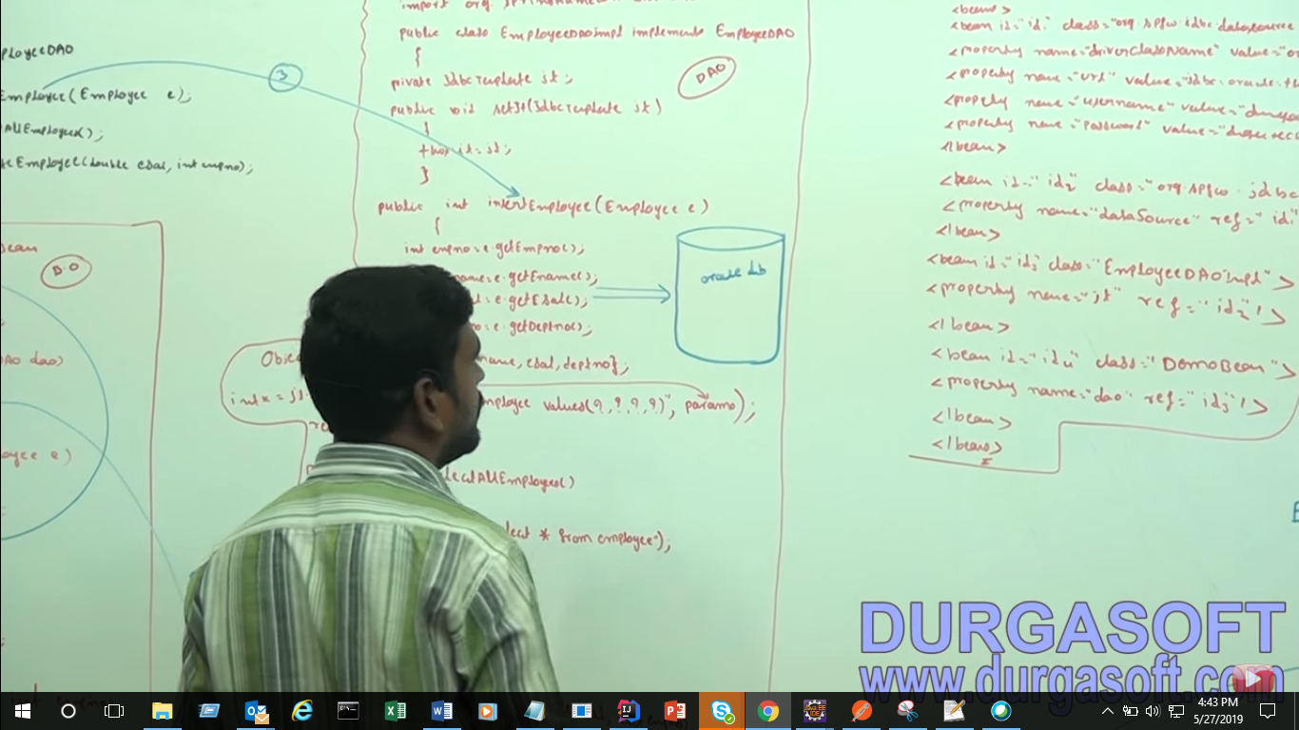 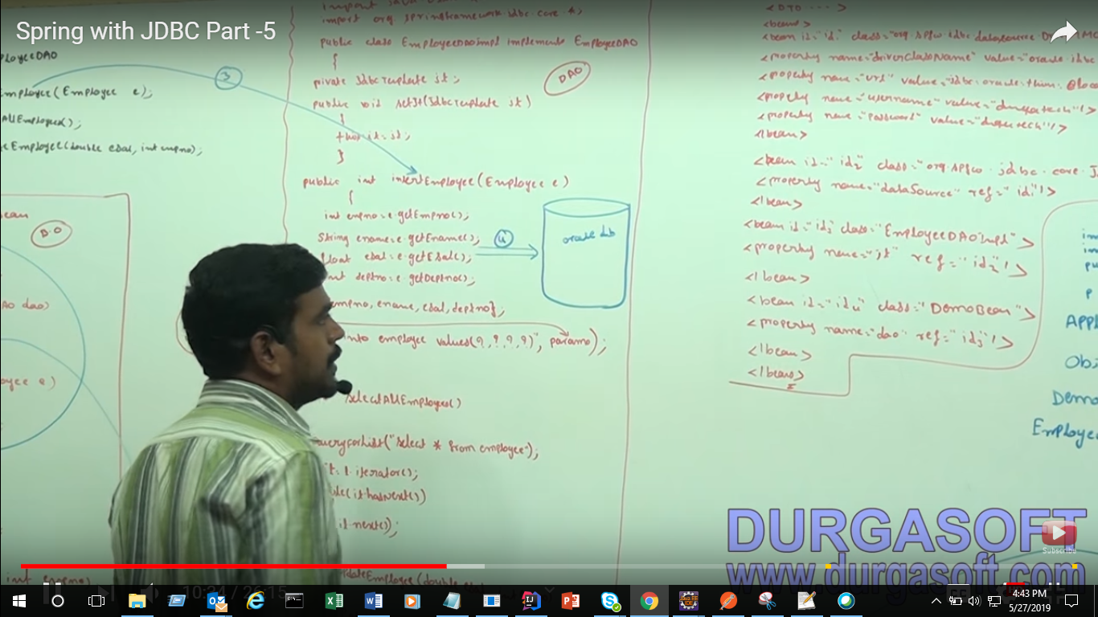

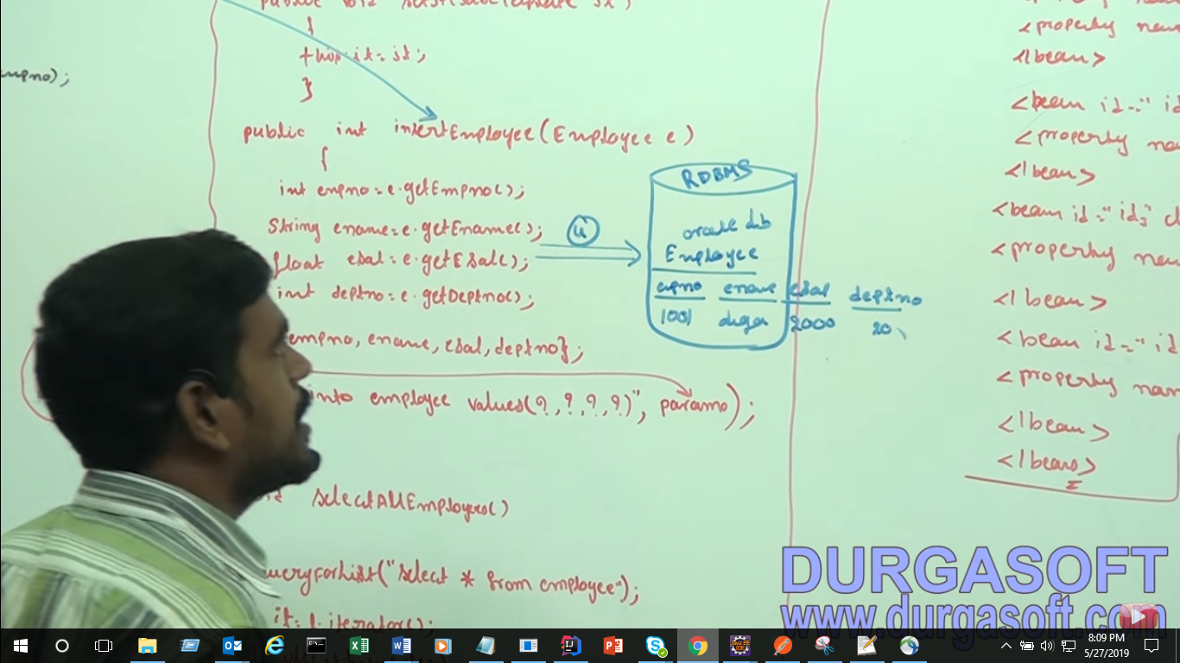

Component means Class

In future we will use Hibernate and we only change this deo method insertEmploee() content(andar wala part)

Now we will talk about selecting the records select AllEmployee()

If this method will executed output will like this:

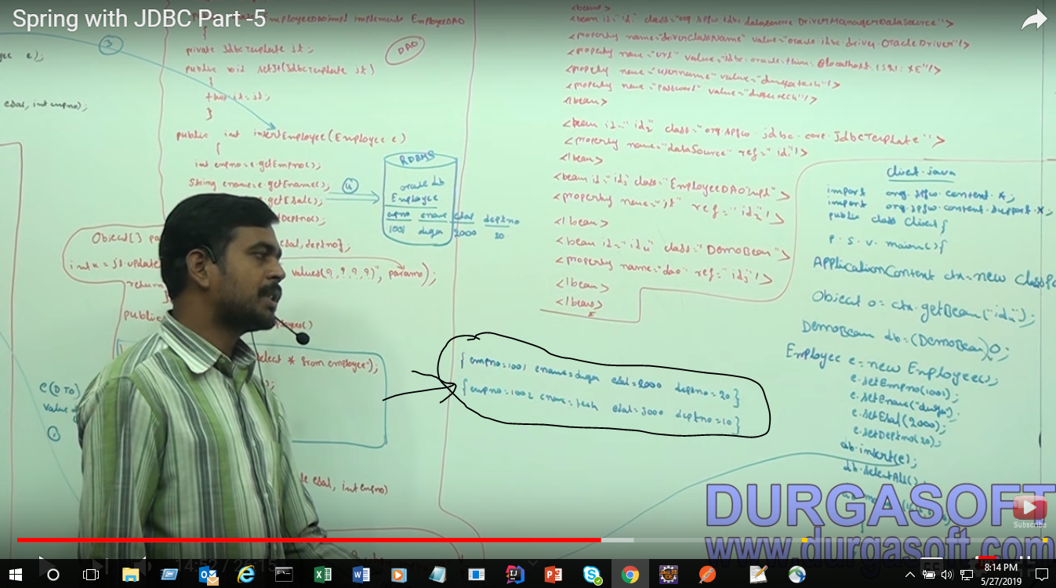

Now that’s fine for one or two recodes if records will much then we will have problem

Here we are using List and iterating a recode but internally this method is working ?

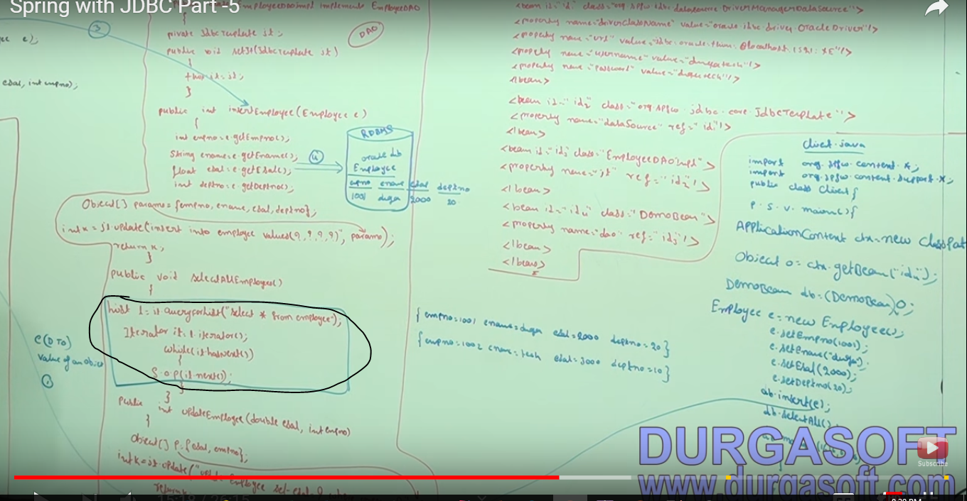

First Value will come to result set object like this :

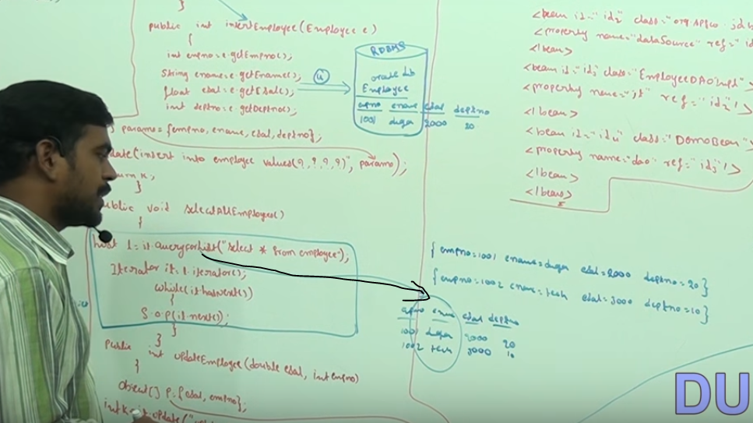

Then it will convert into map object and each row will map like this:

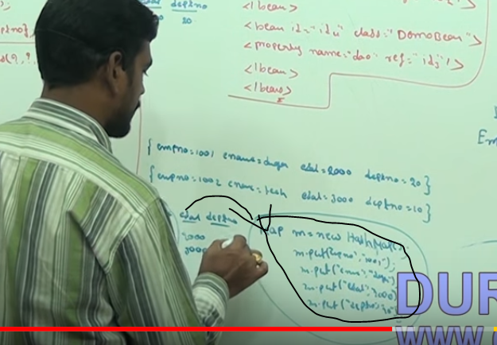

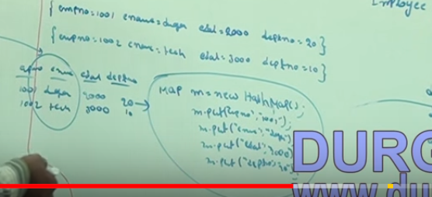

Then after that map will store into list

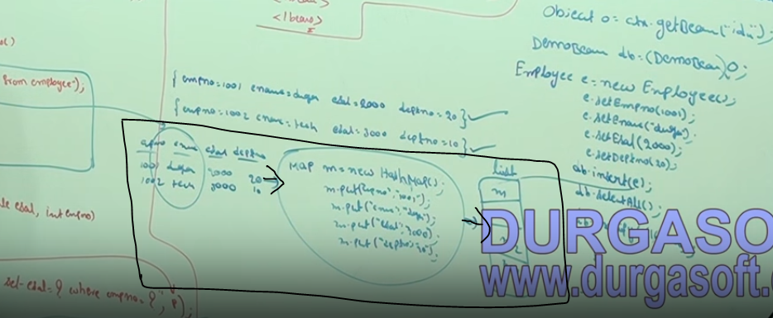

If we have thousands of recorded then these many conversing will get performants issue :

For ovee come this problem we have rowmapper concept for that you have implement rowmapper interface

RowMapper class :

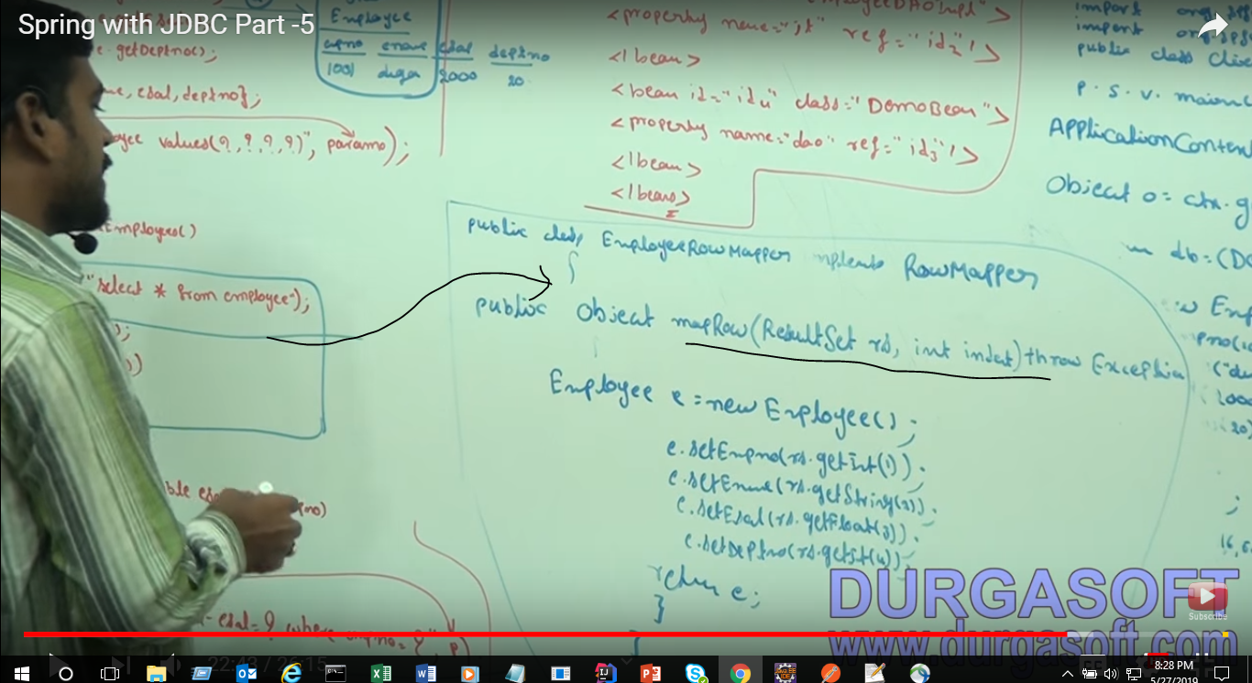

For Implementation for this we need to eliminate this please of code :

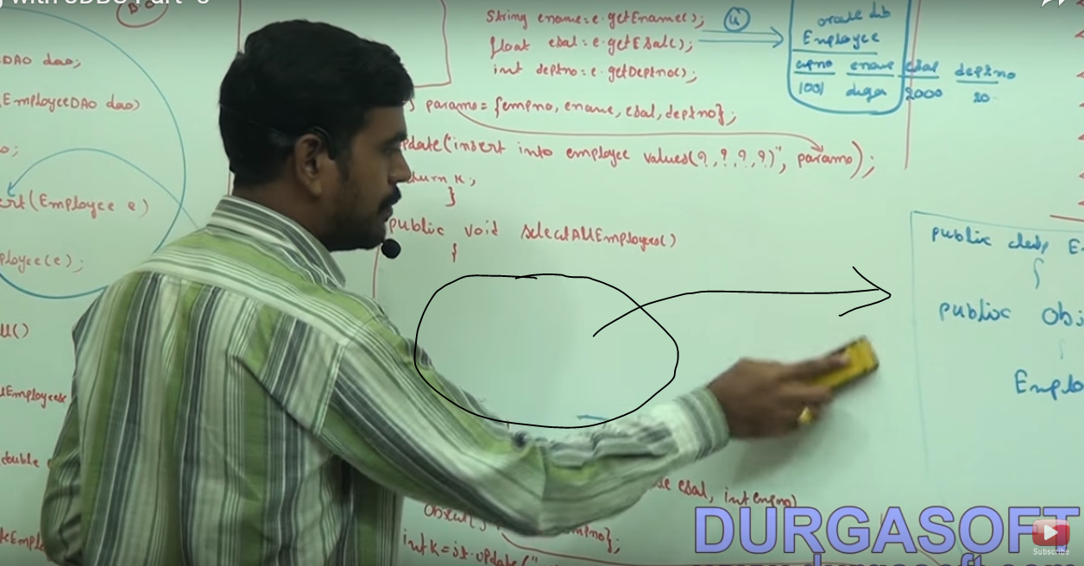

We pass as arguments like this :

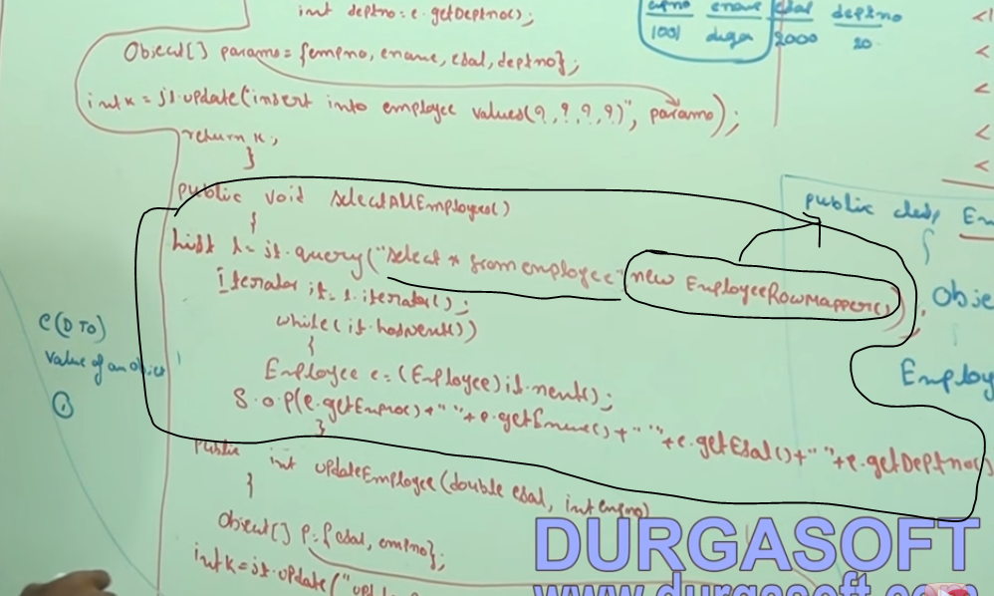

Spring with JDBC Part -6

<https://youtu.be/__tkQZXe7rQ>

Plaese visit once again only 14 min vide

Implantation of Row mapper which is provided by Spring :

If you are using this approach you will get meta data with data like this:

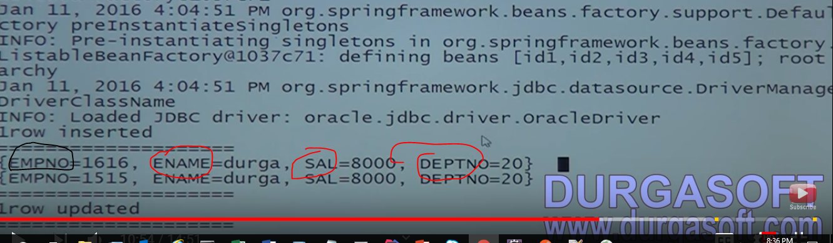

EmpNo,Ename,Sal,DeptNo are meta data

This not good approach it will decrease perform overcome so go for Rowmapper

After Using Row mapper will get o/p like this :

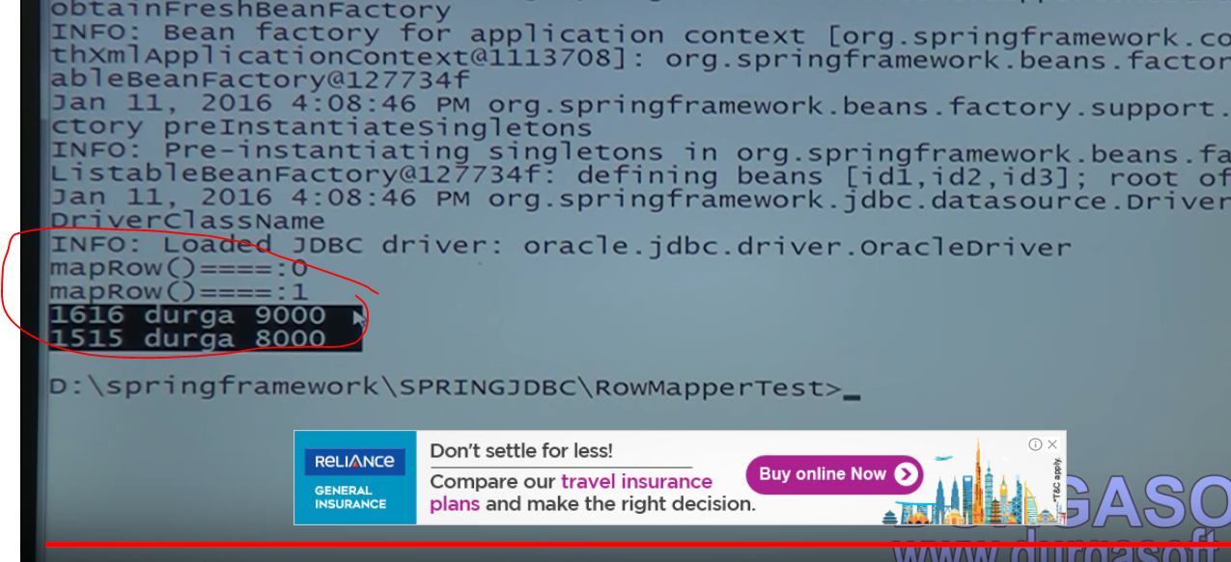

If 1000 of recodes are there and if meta data also coming then our application performance will get decrease and response time will be more

# Spring with JDBC Part -7

This for stored procedure

https://youtu.be/_8X3jEAljaI

Here you can learn how to call procedure, In order to use store procedure our class must and should extends our class to stored procedure

Instead of directly hitting the data base we can call producer using storedproducre we can inhance our application preformation

StoredProdure : In parameters that means giving input, and Out parameters